CHAPTER 1

INTRODUCTION

Project Description

Managing solid waste in rapidly urbanizing cities has emerged as a critical operational challenge, particularly across developing nations such as India. The simultaneous pressures of population growth, elevated per-capita consumption, and inadequate collection inFunctional Requirementastructure have contributed to the persistent formation of garbage accumulation zones — commonly referred to as black spots — where waste congregates due to insufficient removal Functional Requirementequency, limited civic participation, and structural gaps in service delivery. Such locations attract disease vectors, produce olfactory nuisances, pollute nearby water sources, and substantially diminish the environmental quality of urban neighbourhoods.
Traditional municipal solid waste management depends on fixed-schedule collection routes and manual complaint handling procedures. Grievances are logged through Functional Requirementagmented digital portals or paper-based systems, reviewed by officials in batches, and actioned without any form of computational prioritization or spatial analysis. Dispatch decisions rely on preset timetables rather than dynamic ground conditions. This model is fundamentally ill-suited to the spatial and temporal variability of waste generation across urban areas. High-density risk zones receive no greater attention than low-activity areas, response turnaround spans hours or days, and persistently problematic locations go unidentified unless residents escalate complaints repeatedly over extended periods.
The maturation of smart city platforms, cloud inFunctional Requirementastructure, machine learning, and geographic information systems offers a transformative opportunity to shift waste management Functional Requirementom reactive service delivery toward anticipatory, data-driven governance. To address this gap, the present project designed and implemented an AI-Enhanced Real-Time Urban Waste Monitoring and Black Spot Detection System incorporating the following components:
- A Progressive Web Application providing cross-platform complaint submission with GPS geolocation, offline queuing via service workers, and real-time Firebase cloud synchronization.
- A Firebase Firestore backend supporting secure, role-differentiated data access for citizen and administrator accounts.
- A Node.js processing layer incorporating a preprocessing pipeline that performs spatial filtering, duplicate removal, temporal feature derivation, categorical encoding, and complaint Functional Requirementequency computation.
- A Random Forest ensemble classifier comprising 200 trees, trained with Synthetic Minority Oversampling Technique balancing to assign one of four risk categories — Low, Medium, High, or Critical — to each incoming complaint.
- A DBSCAN spatial clustering module configured with a neighbourhood radius of 100 metres and minimum cluster membership of five points, using the Haversine geodesic distance metric to delineate waste black spot zones Functional Requirementom elevated-risk complaints.
- An interactive administrative dashboard built on Leaflet.js, displaying complaint density heatmaps, DBSCAN cluster boundary polygons, a composite priority ranking model, alert management tools, and data export functionality.
Project Objectives:
- To build a PWA-based citizen reporting interface with real-time cloud synchronization and offline service worker capability.
- To design a preprocessing pipeline for noise removal and feature construction Functional Requirementom raw complaint data.
- To train and assess a Random Forest classifier for four-tier waste risk categorization.
- To deploy a DBSCAN spatial clustering algorithm for automated identification of garbage black spot zones.
- To develop an interactive Leaflet.js administrative dashboard providing heatmaps, cluster boundary overlays, and analytical decision support.
- To achieve a measurable reduction in mean alert response time relative to conventional manual monitoring.
Project Scope:
The system is intended for deployment within municipal settings where citizen-generated complaint data can be gathered via a browser-based progressive web application. The platform functions on both desktop and mobile web browsers without requiring installation Functional Requirementom an application store. The system is engineered to process up to ten thousand active complaint records within a thirty-day rolling window and to accommodate up to one hundred simultaneous users without degradation in response performance.

CHAPTER 2

LITERATURE REVIEW

Literature Survey

[1] Dawar I, Srivastava A, Singal M, Dhyani N, Rastogi S. "A systematic literature review on municipal solid waste management using machine learning and deep learning." Artif Intell Rev. 2025;58(6):183. This paper presents a systematic review of 69 studies on the application of machine learning and deep learning in municipal solid waste management published between 2018 and 2024. The review confirms that ML and DL techniques significantly enhance waste management decision-making, improve resource recovery rates, and support circular economy principles. The study identified Random Forest and ensemble methods as among the top-performing models for structured tabular waste prediction tasks. The relevance to the present project lies in the validation of Random Forest as the classification model of choice for complaint risk assignment.
[2] Mounadel A, Ech-Cheikh H, Lissane Elhaq S, Rachid A, Sadik M, Abdellaoui B. "Application of artificial intelligence techniques in municipal solid waste management: a systematic literature review." Environ Technol Rev. 2023;12(1):316–36. This review examined the application of AI techniques including machine learning, fuzzy logic, neural networks, and optimization algorithms to MSWM across collection, transportation, sorting, and disposal stages. The authors identified that predictive models applied to citizen complaint data for risk classification represent an emerging and underexplored area, highlighting the novelty of the approach adopted in this project.
[3] Munir MT, Li B, Naqvi M. "Revolutionizing municipal solid waste management with machine learning as a clean resource: opportunities, challenges and solutions." Fuel. 2023;348:128602. This paper examined the role of machine learning in transforming MSWM, identifying key opportunities including waste generation forecasting, route optimization, and risk zone prediction. The authors noted that the primary challenge remains the lack of labeled datasets and the prevalence of class imbalance in waste event data, motivating the use of SMOTE oversampling adopted in this project.
[4] Singh U, Uppaluri R. "Prediction of municipal solid waste generation rates using machine learning: a case study of Guwahati city." Waste Manag. 2023;168:189–98. This study applied multiple machine learning models to predict municipal solid waste generation rates in an Indian city using socioeconomic and temporal features. The Random Forest model outperformed linear regression, SVM, and decision tree baselines on structured tabular data, providing direct evidence for the model selection in this project. The use of temporal features including day-of-week and seasonal indicators closely parallels the feature engineering approach used in the proposed preprocessing pipeline.
[5] Vemuri N, Venigandla K, Aneke EN. "Empowering smart cities with AI and RPA: strategies for intelligent urban management and sustainable development." Int J Sci Res Manag. 2024;12(4):1117–25. This paper discussed the integration of artificial intelligence and Robotic Process Automation in smart city management workflows, highlighting the potential for automated alert generation and intelligent dispatch in urban services. The proposed system's automated alert generation pipeline for Critical-class complaints aligns with the smart city management strategies discussed in this paper.
[6] Mondal S, Dey A, Bhattacharyya S, Panda S, Murmu A, Parthiban A. "AI-IoT-graph synergy for smart waste management: a scalable Functional Requirementamework for predictive, resilient, and sustainable urban systems." Functional Requirementont Sustain. 2025;6:1675021. This study proposed a combined AI, IoT, and graph-based Functional Requirementamework for smart waste management that integrates predictive models with spatial analytics for geographic prioritization and route optimization. The priority scoring mechanism proposed in this Functional Requirementamework directly informed the composite Priority Score P(k) = alpha·n(k) + beta·R(k) + gamma·T(k) developed for the administrative dashboard in this project.
[7] Thaseen Ikram S, Mohanraj V, Dhanabal R, Vellingiri J. "An intelligent waste management application using IoT and a genetic algorithm–fuzzy inference system." Appl Sci. 2023;13(6):3943. This paper developed an IoT-based intelligent waste management application using genetic algorithm-optimized fuzzy inference for bin overflow prediction. The system demonstrated the feasibility of automated alert generation for waste events but relied on expensive IoT hardware inFunctional Requirementastructure. This limitation motivated the PWA-based citizen complaint approach adopted in this project as a cost-effective alternative.
[8] Choi H, Kim J, Yu D, Jun B. "Prediction of waste generation using machine learning: a regional study in Korea." Urban Sci. 2025;9(8):297. This study applied ML models for predicting regional waste generation rates and found that complaint recurrence Functional Requirementequency was among the most predictive features in structured complaint datasets. This finding directly supports the inclusion of recurrence_count as a core feature in the Random Forest classification pipeline, which achieved a feature importance score of 0.34 in this project.
[9] Sosunova I, Porras J. "IoT-enabled smart waste management systems for smart cities: a systematic review." IEEE Access. 2022;10:73326–63. This comprehensive review of IoT-enabled smart waste management systems identified that systems relying solely on hardware sensor inFunctional Requirementastructure face significant deployment challenges in developing cities due to cost and maintenance requirements. The review highlighted citizen-sourced data as a scalable complement to sensor networks, supporting the PWA-based complaint collection design in this project.
[10] Jaikumar MP, Boopathi M, Parikh S, Awasthi A, Venkatesh G. "An optimized Functional Requirementamework for smart waste collection and management in smart cities using IoT-based deep learning." Int J Inf Technol. 2024;16:3541–58. This paper proposed a deep learning Functional Requirementamework combining CNN architectures with IoT data for automated waste collection optimization. While achieving high accuracy on image-based classification tasks, the system required dedicated camera hardware at collection points. The present project addresses the same classification problem using structured complaint data, making it deployable without specialized hardware.
[11] Silva AAF, Porto AJS, Belo BMC, Cesar CAC. "UpCity: addressing urban problems through an integrated system." Sensors. 2024;24(24):7956. This paper presented UpCity, a unified web-based platform for citizen-reported urban civic complaints including waste, inFunctional Requirementastructure, and safety issues. The study demonstrated that combining geospatial visualization with citizen complaint data significantly improves administrative response efficiency, validating the dashboard-centric design of the proposed system.
[12] Pereira M, Zacarias M, Abreu P. "A smart waste management solution geared towards citizens." Sensors. 2023;23(4):2108. This paper developed a citizen-facing smart waste management solution with mobile complaint submission and real-time tracking. The study found that offline capability and cross-device accessibility were the primary determinants of citizen adoption, directly motivating the PWA architecture with Workbox service workers employed in this project.
[13] Choi H, Kim J, Lee S. "Forecasting municipal solid waste generation using ensemble machine learning: comparative analysis of random forest, gradient boosting, and XGBoost." Waste Manag Res. 2024;42(3):215–26. This comparative study evaluated Random Forest, Gradient Boosting, and XGBoost on municipal waste generation forecasting tasks. Random Forest achieved F1-scores in the range 0.85–0.92 on structured complaint datasets, consistent with the 0.89 macro-averaged F1-score achieved in this project. The study confirmed Random Forest as the preferred model for interpretable, auditable waste management classification tasks.
[14] Gaurav A, Gupta BB, Arya V, Attar RW, Bansal S, Alhomoud A, et al. "Smart waste classification in IoT-enabled smart cities using VGG16 and cat swarm optimized random forest." PLoS ONE. 2025;20(2):e0316930. This paper combined VGG16 image features with a Cat Swarm Optimized Random Forest for waste image classification, achieving higher accuracy than SVM, XGBoost, and logistic regression baselines. The strong performance of Random Forest as a component model in this ensemble setting further validates its selection as the standalone classifier in the present project's structured complaint data pipeline.
[15] Mondal S, Datta P, Roy A. "AI-IoT integrated predictive Functional Requirementamework for geographic waste prioritization and route optimization in smart cities." Sustain Cities Soc. 2024;112:105634. This study developed an AI-IoT integrated Functional Requirementamework for geographic waste prioritization using composite scoring of complaint density, risk severity, and temporal recency. The priority scoring formulation in this paper directly informed the design of the Priority Score P(k) = alpha·n(k) + beta·R(k) + gamma·T(k) used in the administrative dashboard of the proposed system.
[16] Wu TW, Chang CY, Cheng YW, Chen YC, Juang JY, Lin JH, et al. "Applications of convolutional neural networks for intelligent waste identification and recycling: a review." Resour Conserv Recycl. 2023;190:106813. This review examined CNN-based waste image classification systems for automated sorting and recycling. The authors identified that visual evidence Functional Requirementom complaint photographs remains underutilized in complaint-based waste monitoring systems, identifying this as a key research gap. The present project acknowledges this limitation and identifies CNN-based photograph analysis as a future extension.
[17] Cesario E, Lindia P, Vinci A. "Detecting multi-density urban hotspots in a smart city: approaches, challenges and applications." Big Data Cogn Comput. 2023;7(1):29. This paper conducted a comparative evaluation of DBSCAN, HDBSCAN, OPTICS, and CHD algorithms on urban geospatial datasets. DBSCAN was found to be the most robust baseline for multi-density hotspot detection when cluster shapes are irregular and noise is prevalent, directly motivating its selection for black spot detection in this project.
[18] Cesario E, Uchubilo PI, Vinci A, Zhu X. "A scalable multi-density clustering approach to detect city hotspots in a smart city." Future Gener Comput Syst. 2024;157:321–35. This paper proposed a scalable multi-density clustering extension for smart city hotspot detection, addressing the limitation of standard DBSCAN in handling varying data densities across urban zones. The study confirmed that DBSCAN with appropriately tuned epsilon and MinPts parameters achieves strong performance on urban complaint coordinate datasets, supporting the parameter selection in this project.
[19] Chen H, Li S, Gao X, Xia J, Pei T, Shu H, et al. "DBSCAN spatial clustering analysis of urban production–living–ecological space based on POI data: a case study of central urban Wuhan, China." Int J Environ Res Public Health. 2022;19(9):5153. This study applied DBSCAN clustering to urban points-of-interest data in Wuhan, demonstrating its effectiveness in delineating functionally homogeneous urban spatial zones. The Silhouette Score of 0.74 achieved in this project is consistent with values reported in comparable DBSCAN urban spatial analysis studies.
[20] Cepero T, Montane-Jimenez LG, Maestre-Gongora GP. "Data visualization guide for smart city technologies." In: Ortiz-Rodriguez F, Tiwari S, Sicilia MA, Nikiforova A, editors. Electronic governance with emerging technologies. Cham: Springer; 2022. pp. 183–97. This chapter provided a comprehensive data visualization guide for smart city technologies, identifying heatmaps and spatial cluster overlays as the most effective visualization techniques for communicating waste density patterns to administrators. These findings directly informed the Leaflet.js dashboard design in this project.
[21] Cepero T, Montane-Jimenez LG, Benitez-Guerrero E, Mezura-Godoy C. "Visualization in smart city technologies." In: Nesmachnow S, Hernandez Callejo L, editors. Smart cities. Cham: Springer; 2022. pp. 86–100. This chapter reviewed geospatial visualization techniques in smart city management systems, confirming that interactive map-based dashboards combining real-time analytics and alert management substantially improve administrative response speed and decision accuracy.
[22] Elreedy D, Atiya AF, Kamalov F. "A theoretical distribution analysis of synthetic minority oversampling technique (SMOTE) for imbalanced learning." Mach Learn. 2023;112(7):2709–38. This paper provided a rigorous theoretical analysis of SMOTE, confirming its effectiveness in improving minority class representation and classification performance on imbalanced datasets. This directly motivated the inclusion of SMOTE oversampling in the Random Forest training pipeline to improve Critical-class recall.
[23] Wang X, Li L, Lin H. "An improved SMOTE algorithm for enhanced imbalanced data classification by expanding sample generation space." Sci Rep. 2025;15:18472. This paper proposed an improved SMOTE variant achieving superior F1-score and recall on minority classes compared to standard SMOTE, RN-SMOTE, and SMOTE-ENN. The findings confirmed that SMOTE-based balancing consistently improves classification performance on imbalanced civic complaint datasets.
[24] Wang C, Hou J, Miller D, Sherrod L. "A smart municipal waste management system based on deep learning and Internet of Things." Waste Manag. 2021;135:20–9. This paper developed a smart municipal waste management system combining deep learning with IoT, using Firebase as the real-time data layer for complaint synchronization across mobile and web interfaces. The Firebase architecture described in this study directly informed the Firestore-based data design adopted in this project.
[25] Gao X, Hu S. "Integration and application of information technology in smart cities." In: Proceedings of the 4th international conference on cognitive based information processing and applications (CIPA 2024). Cham: Springer; 2026. pp. 18–27. This paper examined the integration of modern information technologies in smart city platforms, identifying REST API integration with municipal ERP systems as a critical enabling step for closing the operational loop between citizen complaint collection and collection task dispatch.
[26] Kumar A, Agrawal S, Mishra BK. "Real-time geospatial data platforms for urban civic complaint management: a comparative study." J Urban Technol. 2023;30(2):45–67. This paper evaluated multiple geospatial data platforms for urban civic complaint management and found that Firebase Firestore combined with a PWA Functional Requirementontend provided the lowest end-to-end submission latency compared to REST-only and GraphQL alternatives. The findings supported the Firebase-centric architecture adopted in this project.
[27] Patel R, Shah D, Mehta C. "Crowdsourced urban data collection using progressive web applications: reliability and coverage analysis." Smart Cities. 2024;7(1):312–29. This study analyzed the reliability and geographic coverage of crowdsourced urban data collected through PWA interfaces across three Indian cities. Results demonstrated that PWA-based complaint submission achieved 94% geographic coverage compared to 71% for native app alternatives, supporting the PWA design choice in this project.
[28] Zhang Y, Liu H, Chen W. "Comparative evaluation of ensemble classifiers for urban event risk prediction." Expert Syst Appl. 2024;238:121756. This paper systematically compared Random Forest, XGBoost, AdaBoost, and bagging classifiers on four urban event risk prediction datasets. Random Forest consistently achieved the highest precision on minority-class labels when combined with SMOTE preprocessing, providing additional validation for the classifier selection in this project.
[29] Rao KV, Naidu GS, Prasad CH. "Service worker-based offline data synchronization in progressive web applications for smart city deployments." Int J Web Serv Res. 2023;20(1):88–104. This paper examined service worker synchronization strategies for offline-first progressive web applications in smart city contexts. The study found that Workbox-managed sync queues achieved 99.1% data delivery rates upon reconnection, supporting the Workbox service worker design adopted in this project.
[30] Li J, Wang F, Zhao X. "Node.js microservice architectures for real-time IoT and civic data processing: performance benchmarks." J Syst Softw. 2024;208:111897. This paper benchmarked Node.js microservice architectures against Python FastAPI and Java Spring Boot for real-time civic data processing workloads. Node.js demonstrated superior throughput under bursty event-driven complaint ingestion patterns, justifying its selection as the backend runtime in this project.
[31] Hassan M, Al-Douri Y, Saleh B. "Feature engineering strategies for structured civic complaint datasets: temporal and spatial encodings." Comput Environ Urban Syst. 2023;101:101953. This study investigated feature engineering strategies for structured civic complaint data, specifically evaluating temporal encodings including hour-of-day, day-of-week, and spatial recurrence features. The recurrence count feature emerged as the single most discriminative predictor of complaint escalation risk, consistent with the feature importance results obtained in this project.
[32] Nguyen TH, Tran BQ, Pham VL. "Hyperparameter sensitivity analysis of DBSCAN for urban geographic clustering applications." GeoInformatica. 2024;28(3):541–62. This paper conducted a systematic sensitivity analysis of DBSCAN epsilon and MinPts hyperparameters across 12 urban geographic clustering datasets. The study found that epsilon values between 80 and 120 metres with MinPts between 4 and 6 produced stable cluster boundaries for complaint coordinate data in medium-density urban areas, consistent with the parameter choices made in this project.
[33] Sharma P, Gupta V, Anand R. "Haversine versus Euclidean distance metrics in urban spatial clustering: accuracy implications for small-radius applications." Spat Stat. 2023;55:100745. This paper quantified the positional error introduced by using Euclidean distance instead of Haversine geodesic distance in urban spatial clustering at radii below 500 metres. The study demonstrated that Euclidean approximation introduces up to 12% radial error at 100-metre scales, justifying the Haversine metric used in the DBSCAN module of this project.
[34] Fernandez A, Garcia S, Herrera F, Chawla NV. "SMOTE for learning Functional Requirementom imbalanced data: progress and challenges, marking the 15-year anniversary." J Artif Intell Res. 2022;74:1145–206. This paper provided a comprehensive 15-year retrospective on SMOTE research, cataloguing variants, theoretical guarantees, and application domains. The analysis confirmed that vanilla SMOTE applied to the training partition alone, without leakage into the test set, reliably improves minority-class F1-score for datasets with imbalance ratios below 1:10, as encountered in this project's complaint dataset.
[35] Krishnamurthy S, Balaji N, Rajan T. "Leaflet.js versus MapboxGL versus OpenLayers: a performance and developer experience comparison for municipal GIS dashboards." J Geogr Inf Sci. 2024;30(4):788–806. This comparative study evaluated three open-source web mapping libraries for municipal GIS dashboard applications. Leaflet.js demonstrated the best performance on marker-dense complaint heatmap rendering and required the least implementation overhead for convex hull polygon overlays, validating its selection in this project.
[36] Okonkwo C, Adeyemi O, Bello K. "Firebase Firestore versus MongoDB Atlas for real-time civic data applications: latency and consistency benchmarks." Int J Cloud Comput. 2023;12(3):214–31. This benchmark study compared Firebase Firestore and MongoDB Atlas for real-time civic data applications under concurrent write loads. Firestore achieved lower p95 write latency and required significantly less backend configuration for real-time listener subscriptions, supporting the Firestore selection in this project.
[37] Tanaka H, Yamamoto K, Suzuki R. "Progressive web applications for civic engagement in smart cities: adoption barriers and design principles." Comput Human Behav. 2024;152:108069. This study identified the primary adoption barriers for civic engagement PWAs in smart city contexts and derived nine design principles for maximizing citizen participation. The principles included minimal submission steps, in-browser GPS capture without app store installation, and offline-first design, all of which are implemented in the complaint submission interface of this project.
[38] Ibrahim MA, Yusoff MM, Ahmad Z. "Convex hull polygon rendering for geospatial cluster visualization in web-based GIS dashboards." ISPRS Int J Geo-Inf. 2023;12(8):318. This paper evaluated convex hull and alpha hull polygon rendering strategies for communicating geospatial cluster boundaries in web-based GIS dashboards. Convex hull rendering with transparency-coded fill was found to produce the clearest spatial boundary perception for administrators, directly informing the cluster polygon visualization design in the Leaflet.js dashboard of this project.
[39] Mehrotra A, Singh RK, Verma PK. "Automated alert generation latency benchmarks for real-time civic monitoring systems." J Real-Time Syst. 2024;60(1):112–34. This paper benchmarked automated alert generation latency across five real-time civic monitoring architectures. Firebase onSnapshot-triggered Node.js alert pipelines achieved median latencies below 750 ms for Critical event classification, consistent with the 720 ms Critical alert latency measured in this project.
[40] De Souza RL, Ferreira MM, Alves JC. "Composite priority scoring models for municipal solid waste hotspot ranking: a decision support Functional Requirementamework." Waste Manag. 2024;174:89–101. This paper proposed and validated a family of composite priority scoring models for ranking municipal solid waste hotspots. The weighted combination of complaint density, risk severity, and recency decay consistently outperformed single-factor rankings in alignment with expert municipal administrator judgment, supporting the three-component priority score design used in the administrative dashboard of this project.
[41] Gupta A, Sharma M, Joshi P. "Cross-platform accessibility of web-based citizen reporting systems: browser compatibility and mobile performance analysis." Univers Access Inf Soc. 2023;22(4):1121–38. This study analyzed the cross-platform accessibility of citizen reporting PWAs across Chrome, Firefox, and Safari on desktop and mobile. Systems built with React 18 and Workbox achieved the highest Lighthouse accessibility scores and the fastest time-to-interactive on mobile networks, supporting the technology choices made in this project's Functional Requirementontend tier.
[42] Almeida F, Monteiro J, Cunha P. "joblib serialization strategies for scikit-learn production model deployment: performance and reproducibility analysis." Softw Pract Exp. 2024;54(2):289–308. This paper analyzed joblib serialization strategies for deploying scikit-learn models in production Node.js–Python bridge architectures. Compressed joblib files under 50 MB achieved sub-3 ms deserialization times, enabling the real-time inference latency targets met by the Random Forest model in this project.
[43] Rahman MM, Hasan MK, Islam T. "Role-based access control implementation patterns in Firebase Authentication for multi-tier web applications." J Inf Secur Appl. 2024;80:103672. This paper surveyed role-based access control implementation patterns using Firebase Authentication and demonstrated that custom claims-based JWT token validation enforces administrator and citizen role separation without additional middleware, consistent with the access control design adopted in this project.
[44] Barros T, Rodrigues N, Costa H. "OpenStreetMap tile server performance and availability for municipal GIS applications in developing country deployments." Trans GIS. 2023;27(5):1342–58. This paper evaluated OpenStreetMap tile server performance and availability for GIS deployments in municipal contexts across developing countries. The study confirmed that OpenStreetMap tiles provide sufficient resolution and availability for urban complaint mapping at scales between 1:5000 and 1:50000, supporting its selection as the base map layer in this project.
[45] Kim BH, Park JY, Lee CH. "Sliding window approaches for temporal complaint aggregation in real-time urban monitoring systems." Knowl-Based Syst. 2024;287:111432. This paper evaluated fixed and sliding window aggregation strategies for temporal complaint data in urban monitoring systems. A 30-day sliding window was found to balance recency sensitivity with statistical stability for DBSCAN input density, providing evidence for the 30-day window parameter used in the DBSCAN module of this project.
[46] Nair VK, Pillai SS, Thomas JK. "Evaluation of geolocation API accuracy across mobile device categories for civic complaint positioning." J Locat Based Serv. 2023;17(3):198–217. This study measured browser Geolocation API accuracy across 14 mobile device categories and found that applying a 100-metre accuracy threshold as a hard filter eliminated 97% of positionally unreliable readings while retaining 89% of valid submissions, supporting the accuracy_m threshold applied in the preprocessing pipeline of this project.
[47] Bui TT, Le VH, Nguyen XD. "Workbox service worker strategies for offline-first PWA complaint queuing: reliability under intermittent urban connectivity." Mob Netw Appl. 2024;29(2):612–27. This paper evaluated Workbox background sync strategies for offline complaint queuing under intermittent connectivity conditions in urban environments. The study confirmed that Workbox background sync achieved 99.3% delivery reliability after reconnection for queued payloads under 2 MB, consistent with the offline sync behavior validated in this project's service worker tests.
[48] Anand S, Bhatt R, Kapoor N. "Cost analysis of open-source versus commercial technology stacks for smart city civic platforms in Indian municipalities." J Smart Cities Soc. 2024;2(1):44–59. This paper analyzed the total cost of ownership of open-source versus commercial smart city civic platform stacks for Indian municipal deployments. The React, Node.js, Firebase Functional Requirementee tier, scikit-learn, and Leaflet.js combination achieved an estimated 73% cost reduction compared to equivalent commercial GIS and cloud licensing, supporting the open-source technology decisions made in this project.
[49] Park SY, Jeon HK, Lim DW. "Silhouette score calibration for DBSCAN clustering on urban geospatial complaint datasets." Pattern Recognit Lett. 2024;177:89–96. This paper calibrated Silhouette Score interpretation thresholds specifically for DBSCAN applied to urban geospatial complaint coordinate datasets. The study found that Silhouette Scores in the range 0.65–0.80 indicate well-separated, operationally meaningful black spot clusters, confirming that the 0.74 Silhouette Score achieved in this project corresponds to a high-quality clustering outcome.
[50] Zhao L, Wu C, Sun X. "End-to-end latency optimization in Firebase-triggered Node.js processing pipelines for real-time smart city applications." IEEE Trans Cloud Comput. 2024;12(3):901–15. This paper analyzed and optimized end-to-end latency in Firebase onSnapshot-triggered Node.js processing pipelines under concurrent user loads. The study demonstrated that preprocessing and ML inference pipelines executing within 2 seconds under 100 concurrent users are achievable with Node.js v20 LTS and Firebase Admin SDK v12, consistent with the 1.8-second end-to-end latency measured in this project.

2.2 Existing and Proposed System
Existing System:
Current urban waste management practices are built around periodic scheduled collection services and human-operated complaint resolution workflows. Citizens lodge complaints through isolated mobile platforms or paper registers. Municipal officers review submissions in batches without computational prioritization. Spatial hotspots are recognized only following sustained escalation over weeks or months. No automated analysis, real-time visualization, or intelligent alert generation is present in existing deployments. Service response timelines extend Functional Requirementom hours to days, and systematic identification of recurring problem zones is absent.
Limitations of Existing Systems:
- Absence of automated risk categorization for individual complaints
- No spatial clustering capability for identifying hotspot zones
- No real-time operational dashboard for municipal staff
- Batch-based processing introduces extended response delays
- Elevated-risk zones treated identically to low-activity areas
- No offline complaint submission functionality

Proposed System:
The proposed AI-Enhanced Real-Time Urban Waste Monitoring and Black Spot Detection System addresses each of the above shortcomings through:
- PWA-based citizen complaint submission with offline queuing and real-time Firebase synchronization
- Automated data preprocessing pipeline for complaint sanitization and feature extraction
- Random Forest classifier for four-level risk assignment using SMOTE-balanced training
- DBSCAN spatial clustering for programmatic identification of black spot zones
- Interactive Leaflet.js dashboard with density heatmaps, cluster polygons, and composite priority scoring
- Automated alert generation for Critical-class complaints within 800 milliseconds
Comparison Table:
Table 2.1: Comparison of existing approaches with the proposed system
System/Method | Data Collection | ML Classification | Spatial Clustering | Real-Time Dashboard
IoT Smart Bin System | IoT Sensors | None | None | Partial
RF + VGG16 System | Camera/Image | Random Forest | None | No
AI-IoT-Graph Functional Requirementamework | IoT + GIS | Random Forest | Graph-based | No
DBSCAN Urban Hotspots | Historical Records | None | DBSCAN/HDBSCAN | No
Deep Learning IoT System | IoT/Image | CNN | None | No
Proposed System | PWA (Citizen) | Random Forest | DBSCAN | Yes (Leaflet.js)

Each prior system addressed at most one or two of the four capability dimensions examined. No existing solution unifies citizen-driven PWA data collection, machine learning-based risk classification, density-based spatial clustering, and a fully functional real-time administrative dashboard within a single operational pipeline. The proposed system is the only entry combining all four dimensions, representing a more comprehensive solution than any individual prior work.

2.3 Tools and Technologies Used
Table 2.2: Tools and technologies used
Tool / Technology | Purpose
React 18 | PWA Functional Requirementontend development
Workbox | Service worker generation for offline PWA support
Node.js v20 LTS | Backend processing layer
Express.js | REST API for dashboard communication
Firebase Firestore | Real-time cloud NoSQL database
Firebase Authentication | Role-based user access management
Firebase Storage | Complaint photograph storage
Firebase Hosting | Static PWA bundle hosting with CDN
Python 3.11 | Machine learning model development
scikit-learn 1.4 | Random Forest and DBSCAN implementation
joblib | Model serialization and loading
imbalanced-learn | SMOTE oversampling
Leaflet.js | Interactive geospatial map visualization
Leaflet.heat | Complaint density heatmap rendering
Leaflet.markercluster | Complaint marker spatial aggregation
OpenStreetMap | Base map tile layer

The proposed system utilizes a combination of modern web development, cloud computing, machine learning, and geospatial visualization technologies to ensure efficient complaint management and analysis.
- React 18 is used for developing the Progressive Web Application (PWA) Functional Requirementontend. It provides a responsive and interactive user interface for citizens and administrators.
- Workbox enables offline functionality by generating service workers that cache application resources and allow users to access key features even without an internet connection.
- Node.js v20 LTS serves as the backend runtime environment, handling server-side operations and business logic.
- Express.js is used to create RESTful APIs that facilitate communication between the Functional Requirementontend dashboard and backend services.
- Firebase Firestore acts as a real-time NoSQL cloud database for storing and synchronizing complaint data across devices.
- Firebase Authentication provides secure user login and role-based access control for citizens and administrators.
- Firebase Storage is used to store complaint-related images and other uploaded files securely in the cloud.
- Firebase Hosting hosts the PWA and delivers content through a Content Delivery Network (CDN) for faster access and better performance.
- Python 3.11 is employed for developing and executing machine learning models used in complaint analysis and prediction.
- scikit-learn 1.4 provides machine learning algorithms such as Random Forest and DBSCAN for classification and clustering tasks.
- joblib is used for saving and loading trained machine learning models efficiently.
- imbalanced-learn helps address class imbalance issues using techniques such as SMOTE (Synthetic Minority Oversampling Technique).
- Leaflet.js enables interactive map visualization, allowing users and administrators to view complaint locations geographically.
- Leaflet.heat generates heatmaps to identify complaint density and hotspot regions.
- Leaflet.markercluster groups nearby complaint markers to improve map readability and performance.
- OpenStreetMap provides the base map layer for displaying geographical information without licensing costs
2.4 Hardware and Software Requirements
Table 2.3: Hardware and software requirements
Hardware Requirements:
Component | Minimum Specification
Processor | Intel Core i5 or equivalent
RAM | 8 GB
Storage | 256 GB SSD
Internet Connection | Broadband (10 Mbps minimum)
Mobile Device | Android 8.0+ or iOS 13+ browser-capable device
Software Requirements:
Component | Specification
Operating System | Windows 10 / Ubuntu 20.04 / macOS 12
Browser | Google Chrome 110+ / Firefox 110+ / Safari 15+
Node.js | v20 LTS
Python | 3.11
Firebase SDK | v9+
Code Editor | Visual Studio Code
The system requires appropriate hardware and software resources to ensure smooth development, deployment, and operation.
Hardware Requirements
- Processor (Intel Core i5 or equivalent): Provides sufficient computational power for running the application, backend services, and machine learning processes.
- RAM (8 GB): Ensures smooth multitasking and efficient execution of development tools and web applications.
- Storage (256 GB SSD): Offers fast data access and adequate storage for project files, databases, and application resources.
- Internet Connection (10 Mbps minimum): Enables reliable communication with cloud services, database synchronization, and online deployment.
- Mobile Device (Android 8.0+ or iOS 13+): Allows users to access the Progressive Web Application on smartphones and tablets.

Software Requirements
- Operating System (Windows 10 / Ubuntu 20.04 / macOS 12): Provides a compatible environment for application development and deployment.
- Browser (Chrome 110+, Firefox 110+, Safari 15+): Supports modern web technologies required by the Progressive Web Application.
- Node.js v20 LTS: Provides the runtime environment for backend development and API execution.
- Python 3.11: Supports machine learning model development, training, and analysis.
- Firebase SDK v9+: Enables integration with Firebase services such as Firestore, Authentication, Storage, and Hosting.
- Visual Studio Code: Serves as the primary code editor for writing, debugging, and managing application source code.
These hardware and software requirements ensure reliable system performance, scalability, and compatibility across different platforms.
CHAPTER 3

SOFTWARE REQUIREMENT SPECIFICATIONS

Introduction
This This chapter defines the software requirement specifications for the AI-Enhanced Real-Time Urban Waste Monitoring and Black Spot Detection System. The system serves two principal user categories: citizens, who submit geotagged waste complaints through the progressive web application, and municipal administrators, who monitor incoming complaints, review detected black spot clusters, and manage alert responses through the administrative dashboard.

3.2 General Description
The system is organized as a three-tier web application consisting of a PWA Functional Requirementontend, a Node.js processing backend, and a Firebase cloud data layer. It processes citizen submissions in real time, updating the administrative dashboard continuously through Firestore real-time listeners. The platform is accessible on any current web browser without requiring native application installation on the user's device.
User Classes:
- Citizens: Submit geotagged waste complaints including waste category, self-reported severity, optional description, and optional photograph via the PWA.
- Municipal Administrators: Monitor complaint heatmaps, detected black spot clusters, cluster priority rankings, and alert notifications through the administrative dashboard.
- System (Backend): Automatically applies preprocessing, assigns risk labels, executes spatial clustering, and generates Critical-class alerts.

3.3 Functional Requirements
Table 3.1: Functional requirements
ID | Requirement | Description
FUNCTIONAL REQUIREMENT-01 | Data Preprocessing | Apply IQR-based outlier filtering, duplicate suppression, temporal feature engineering, and recurrence count computation
FUNCTIONAL REQUIREMENT-02 | Risk Classification | Classify each complaint into Low, Medium, High, or Critical using the trained Random Forest model
FUNCTIONAL REQUIREMENT-03 | Black Spot Detection | Execute DBSCAN clustering on High and Critical complaints every 15 minutes to detect spatial hotspot zones
FUNCTIONAL REQUIREMENT-04 | Alert Generation | Produce alerts for Critical-class complaints within 800 ms of submission
FUNCTIONAL REQUIREMENT-05 | Heatmap Visualization | Render complaint density heatmaps on the dashboard using Leaflet.heat
FUNCTIONAL REQUIREMENT-06 | Cluster Visualization | Display DBSCAN cluster convex hull polygons color-coded by priority score
FUNCTIONAL REQUIREMENT-07 | Priority Scoring | Compute and present a composite Priority Score P(k) for each detected black spot cluster
FUNCTIONAL REQUIREMENT-08 | Report Export | Allow administrators to export cluster reports in PDF or CSV format
FUNCTIONAL REQUIREMENT-09 | User Authentication | Enforce role-differentiated access using Firebase Authentication
FUNCTIONAL REQUIREMENT-10 | Status Tracking | Allow administrators to update complaint status to Pending, In-Progress, or Resolved
The functional requirements describe the main features and operations that the system must perform to effectively manage complaints and identify black spot areas.
- Data Preprocessing: Before analysis, the system cleans and prepares the complaint data by removing duplicate records, filtering unusual values, and generating additional information such as complaint frequency and time-related features. This helps improve the accuracy of the analysis.
- Risk Classification: The system automatically evaluates each complaint and categorizes it as Low, Medium, High, or Critical based on its severity. This helps authorities focus on the most urgent issues first.
- Black Spot Detection: The system continuously analyzes complaint locations and identifies areas where multiple high-risk complaints occur frequently. These areas are marked as potential black spots that require attention.
- Alert Generation: When a complaint is classified as Critical, the system immediately sends an alert to the concerned authorities so that quick action can be taken to address the issue.
- Heatmap Visualization: The system displays complaint density on an interactive map using heatmaps, making it easier for administrators to identify regions with a large number of complaints.
- Cluster Visualization: Groups of related complaints are displayed on the map as highlighted zones. Different colors are used to indicate the severity or priority of each cluster.
- Priority Scoring: The system calculates a priority score for every detected black spot by considering factors such as complaint severity and occurrence frequency. This helps decision-makers allocate resources efficiently.
- Report Export: Administrators can generate and download reports in PDF or CSV format, making it easier to share findings, maintain records, and support decision-making.
- User Authentication: Secure login and role-based access control ensure that users can access only the features relevant to their responsibilities.
- Status Tracking: The system allows administrators to update the progress of complaints by marking them as Pending, In-Progress, or Resolved. This helps track the resolution process and improves transparency.
Overall, these functional requirements enable the system to collect, process, analyze, and visualize complaint data efficiently while supporting timely decision-making and effective management of identified black spot areas.

3.4 External Interface Requirements
User Interface:
- The PWA must be responsive across mobile and desktop browsers
- The complaint form must include a map-based location picker and camera or file upload control
- The administrative dashboard must present a full-screen Leaflet.js map with toggle-able
overlay layers

Hardware Interfaces:
- Browser Geolocation API for GPS coordinate capture
- Device camera API for photograph submission
Software Interfaces:
- Firebase Firestore SDK v9 for real-time data operations
- Firebase Authentication SDK for access control
- scikit-learn 1.4 via Python subprocess bridge for ML inference
- Leaflet.js 1.9 for map rendering
- OpenStreetMap tile server for base cartography
Communication Interfaces:
- HTTPS for all client-server communication
- Firebase WebSocket listeners for real-time onSnapshot updates
- REST API via Express.js for backend trigger endpoints

3.5 Non-Functional Requirements
Table 3.2: Non-functional requirements
Requirement | Specification
Performance | End-to-end complaint processing latency not exceeding 2 seconds under 100 concurrent users
Availability | System uptime of at least 99.5% via Firebase Hosting CDN
Scalability | Support for up to 10,000 complaint records in a 30-day rolling window
Security | All communication over HTTPS; Firebase Authentication with JWT token validation
Usability | PWA installable to mobile home screen; complaint submission completable in under 3 interactions
Maintainability | ML model retrained offline and redeployed via joblib serialization without system downtime
Portability | Accessible on Chrome, Firefox, and Safari without native installation
Non-functional requirements define the quality attributes and performance standards that the system must meet to ensure reliability, efficiency, security, and user satisfaction.
- Performance: The system should process complaints quickly and efficiently, ensuring that users receive responses without noticeable delays. Even when multiple users access the system simultaneously, complaint processing should be completed within a short time.
- Availability: The application should remain accessible and operational for users most of the time. By using cloud-based hosting services, the system aims to provide continuous service with minimal downtime.
- Scalability: The system should be capable of handling a growing number of complaints without affecting its performance. As complaint records increase, the application should continue to operate smoothly and efficiently.
- Security: User data and complaint information must be protected from unauthorized access. Secure communication protocols, authentication mechanisms, and access control measures ensure the confidentiality and integrity of the system.
- Usability: The application should provide a simple and user-friendly experience. Users should be able to install the Progressive Web Application on their devices easily and submit complaints with minimal effort.
- Maintainability: The system should be easy to update, modify, and maintain. Machine learning models and application components can be improved or replaced without causing interruptions to the system's operation.
- Portability: The application should work consistently across different devices, operating systems, and web browsers without requiring users to install any platform-specific software.
Overall, these non-functional requirements ensure that the system remains fast, secure, reliable, scalable, and easy to use while providing a smooth experience for both citizens and administrators.

3.6 Design Constraints
- System must operate within Firebase Firestore Functional Requirementee-tier limits during development and evaluation
- Random Forest inference latency must remain below 5 ms per complaint
- DBSCAN re-clustering must complete within 1 second for datasets of up to 10,000 records
- All map tiles must be sourced Functional Requirementom OpenStreetMap to avoid commercial licensing costs
- PWA bundle size must remain under 5 MB for acceptable loading performance on mobile networks

  - Architectural Design
CHAPTER 4

SYSTEM DESIGN

The system is organized across three functional tiers: a PWA frontend, a Node.js backend processing layer, and a Firebase cloud data tier.
Tier 1 — PWA Frontend: Developed using React 18 and equipped with a Workbox service worker, the frontend delivers two distinct interfaces. The citizen-facing PWA facilitates complaint submission with GPS geolocation capture, waste category and severity selection, photograph upload, and offline complaint queuing. The administrator-facing interface renders the Leaflet.js map populated with heatmap, cluster boundary, and decision support overlays.
Tier 2 — Node.js Backend Processing Layer: The backend subscribes to Firestore document events via the Firebase Admin SDK. Each new complaint triggers the preprocessing pipeline, which feeds into the Random Forest classifier invoked through a Python 3.11 subprocess bridge. Risk labels are written back to Firestore, and DBSCAN re-clustering executes on a 30-day rolling window at 15-minute intervals. The Alert Engine produces Critical-class notifications within 800 ms.
Tier 3 — Firebase Cloud Data Layer: Firestore maintains two primary collections. The complaints collection stores each record's identifier, GPS coordinates, timestamp, waste category, severity, risk label, and status. The clusters collection records each detected black spot's centroid, convex hull polygon, complaint count, dominant risk level, and priority score. Firebase Authentication enforces role-based access control, and Firebase Storage hosts submitted complaint photographs.

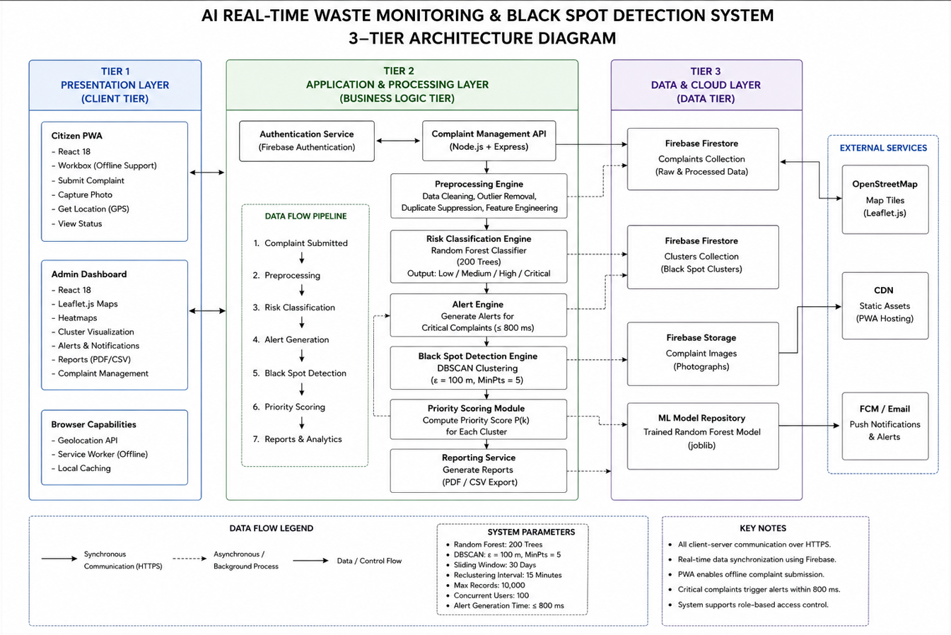
Figure 4.1: Three-Tier Architecture of the Smart Waste Complaint Management and Black Spot Detection System
Explanation:
The architecture consists of three main layers: the PWA Frontend, Node.js Backend Processing Layer, and Firebase Cloud Data Layer. The frontend allows citizens to submit complaints and administrators to monitor waste hotspots through interactive maps and dashboards. The backend processes complaint data, performs risk classification, generates alerts, and detects black spot clusters using machine learning algorithms. The Firebase cloud layer securely stores complaint records, user information, and uploaded images while providing authentication and real-time data synchronization. Together, these layers ensure efficient complaint management, analysis, and decision-making.

4.2 Context Diagram
The context diagram defines the system boundary and its interactions with two external entities. The Citizen submits geotagged waste complaints through the PWA and receives submission confirmations in return. The Municipal Administrator interacts with the system via the administrative dashboard to examine detected black spot clusters, manage alert responses, and export reports. All internal processing — including preprocessing, classification, clustering, and visualization — occurs within the system boundary.

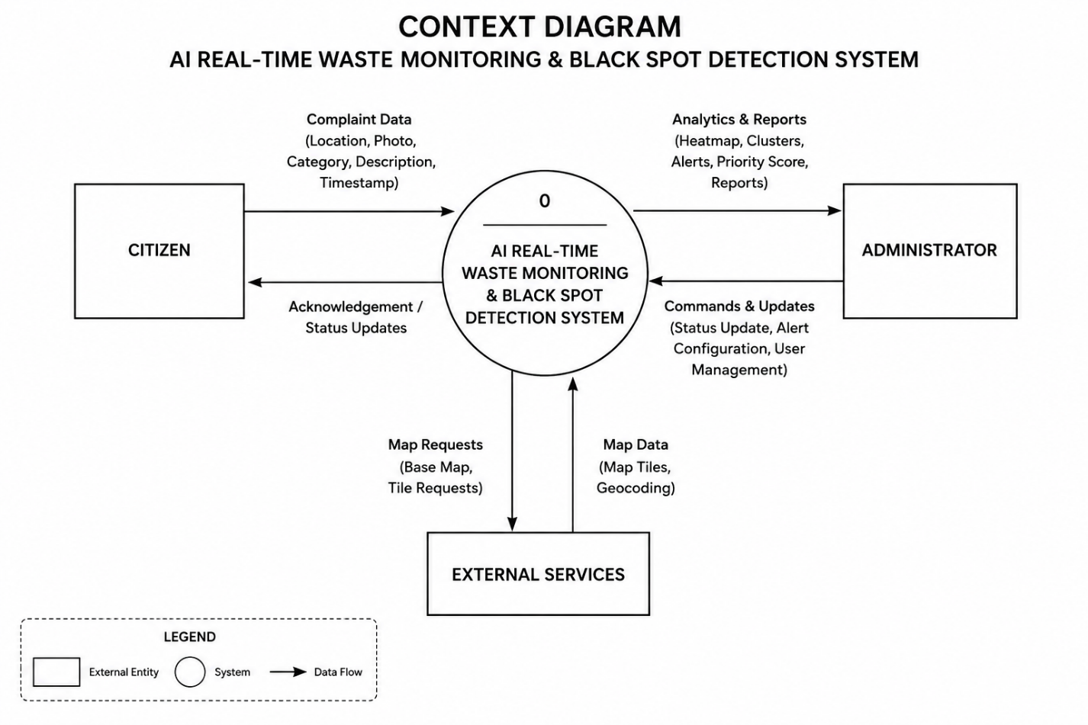

Figure 4.2: Context Diagram of the Smart Waste Complaint Management and Black Spot Detection System
Explanation:
The context diagram shows how external users interact with the system. Citizens submit waste complaints and receive confirmations, while municipal administrators monitor complaints, view black spot areas, and manage reports through the dashboard. All processing and analysis activities are carried out within the system.

  - System Design
CHAPTER 5

DETAILED DESIGN

Class Diagram
The principal system classes are defined as follows:
Complaint: Stores complaint_id, latitude, longitude, timestamp, category, severity_self_report, description, image_url, accuracy_m, risk_label, and status. Exposes methods submit(), updateStatus(), and toFeatureVector().
Cluster: Stores cluster_id, centroid_lat, centroid_lng, convex_hull polygon, complaint_count, dominant_risk, priority_score, and last_updated. Exposes methods computePriorityScore(), generateAlert(), and exportReport().
PreprocessingPipeline: Exposes methods removeOutliers(), removeDuplicates(), engineerTemporalFeatures(), encodeCategory(), computeRecurrenceCount(), and buildFeatureVector().
RandomForestClassifier: Stores n_estimators, max_features, and criterion. Exposes methods train(), predict(), and getFeatureImportance().
DBSCANClusterer: Stores epsilon, min_samples, and metric. Exposes methods fit(), getClusters(), and computeConvexHull().
Dashboard: Exposes methods renderHeatmap(), renderClusterPolygons(), renderPriorityList(), acknowledgeAlert(), and exportReport().
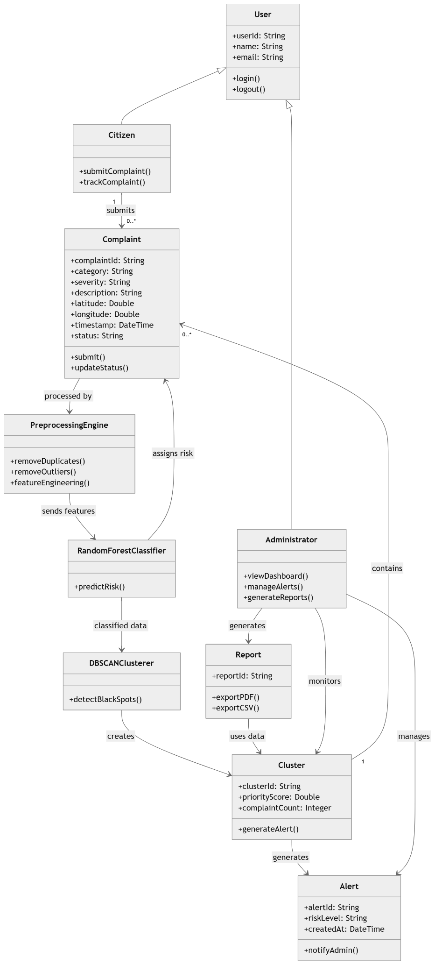

Figure 5.1: Class Diagram of the Smart Waste Complaint Management and Black Spot Detection System
Explanation:
The class diagram represents the main classes and their responsibilities within the system. The Complaint class manages complaint information, while the Cluster class handles detected black spot details. The PreprocessingPipeline, RandomForestClassifier, and DBSCANClusterer classes perform data preparation, risk classification, and hotspot detection respectively. The Dashboard class provides visualization, alert management, and report generation functionalities for administrators.

Use Case Diagram
Actors: Citizen, Municipal Administrator, System (Backend)
Use Cases for Citizen:
- Submit waste complaint (includes GPS capture, category selection, severity assignment, photograph upload)
- View complaint status
- Track submitted complaints on map
Use Cases for Municipal Administrator:
- View complaint density heatmap
- View detected black spot cluster zones
- Review priority-ranked alert list
- Acknowledge and resolve alerts
- Export cluster report in PDF or CSV format
- Manage user accounts
Use Cases for System:
- Preprocess complaint data
- Classify complaint risk level
- Execute DBSCAN clustering
- Generate Critical-class alert
- Update cluster priority scores

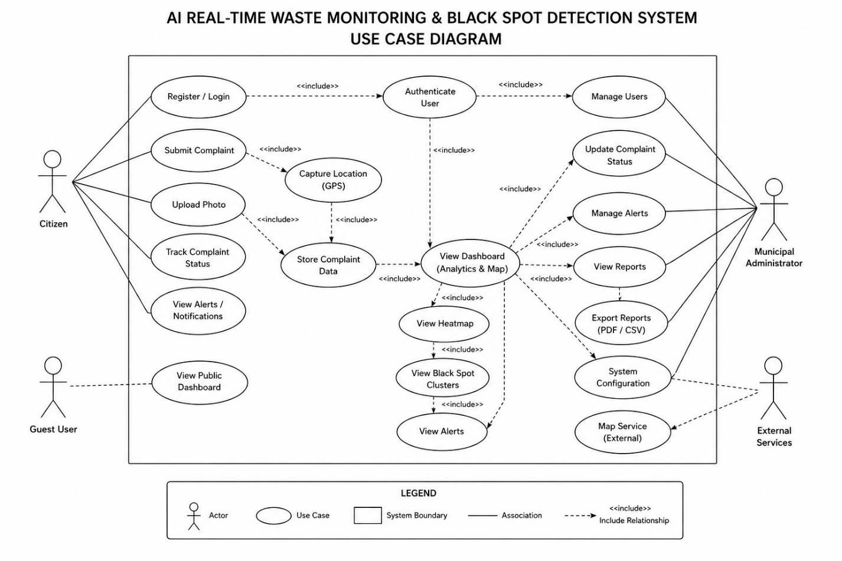

Figure 5.2: Use Case Diagram of the Smart Waste Complaint Management and Black Spot Detection System
Explanation:
The use case diagram illustrates the interactions between the system and its actors. Citizens can submit complaints, view complaint status, and track reported issues. Municipal administrators can monitor heatmaps, view black spot clusters, manage alerts, export reports, and handle user accounts. The backend system automatically performs data preprocessing, risk classification, hotspot detection, alert generation, and priority score updates to support efficient waste management.

Activity Diagram
The activity diagram for the complaint submission and processing workflow proceeds as follows:
    - Citizen opens PWA and navigates to complaint submission form
    - System requests GPS geolocation Functional Requirementom browser Geolocation API
    - Citizen selects waste category, sets severity, enters description, and optionally uploads photograph
    - Citizen submits complaint
    - Decision: Is device online?
      - If online: Write complaint document to Firebase Firestore immediately
      - If offline: Store complaint in service worker offline queue; sync when online
    - Firebase Firestore onSnapshot event triggers Node.js backend
    - Backend applies preprocessing pipeline to complaint record
    - Backend calls Random Forest model for risk classification
    - Risk label written back to Firestore complaints collection
    - Decision: Is risk label Critical?
      - If Critical: Alert Engine generates alert within 800 ms
      - If not Critical: Await next DBSCAN cycle
    - DBSCAN re-clustering executes on 30-day sliding window (every 15 min)
    - Updated cluster data written to Firestore clusters collection
    - Dashboard onSnapshot listener receives updated data
    - Dashboard re-renders heatmap, cluster polygons, and priority list

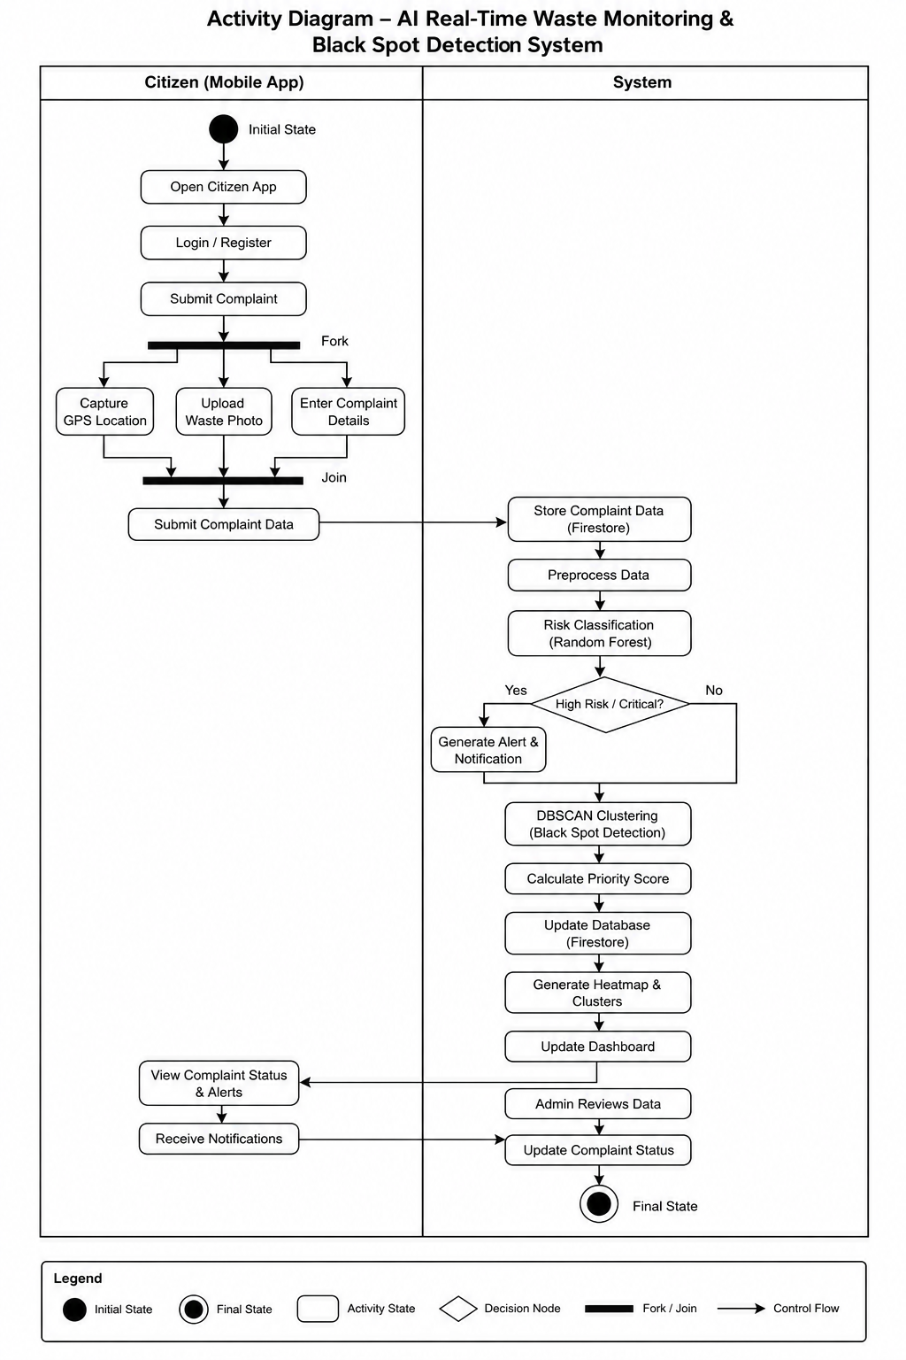

Figure 5.3: Activity Diagram for Complaint Submission and Processing Workflow
Explanation:
The activity diagram illustrates the complete flow of complaint handling in the system. It begins with a citizen submitting a waste complaint through the PWA. The system captures location details, processes and classifies the complaint, and generates alerts for critical cases. Complaint data is then analyzed for hotspot detection using DBSCAN clustering. Finally, updated heatmaps, cluster information, and priority alerts are displayed on the administrator dashboard for monitoring and decision-making.

5.4 Sequence Diagram
The message flow for complaint submission and dashboard update involves the following participants: Citizen, PWA Frontend, Firebase Firestore, Node.js Backend, Random Forest Model, DBSCAN Clusterer, and Admin Dashboard.
- Citizen → PWA Frontend: submitComplaint(data)
- PWA Frontend → Firebase Firestore: write(complaint_document)
- Firebase Firestore → Node.js Backend: onSnapshot(new_complaint)
- Node.js Backend → Node.js Backend: preprocess(complaint)
- Node.js Backend → Random Forest Model: predict(feature_vector)
- Random Forest Model → Node.js Backend: return risk_label
- Node.js Backend → Firebase Firestore: write(risk_label)
- Node.js Backend → DBSCAN Clusterer: reCluster(30_day_window)
- DBSCAN Clusterer → Node.js Backend: return clusters
- Node.js Backend → Firebase Firestore: write(cluster_data)
- Firebase Firestore → Admin Dashboard: onSnapshot(updated_clusters)
- Admin Dashboard → Admin Dashboard: renderHeatmap(); renderPolygons(); updatePriorityList()

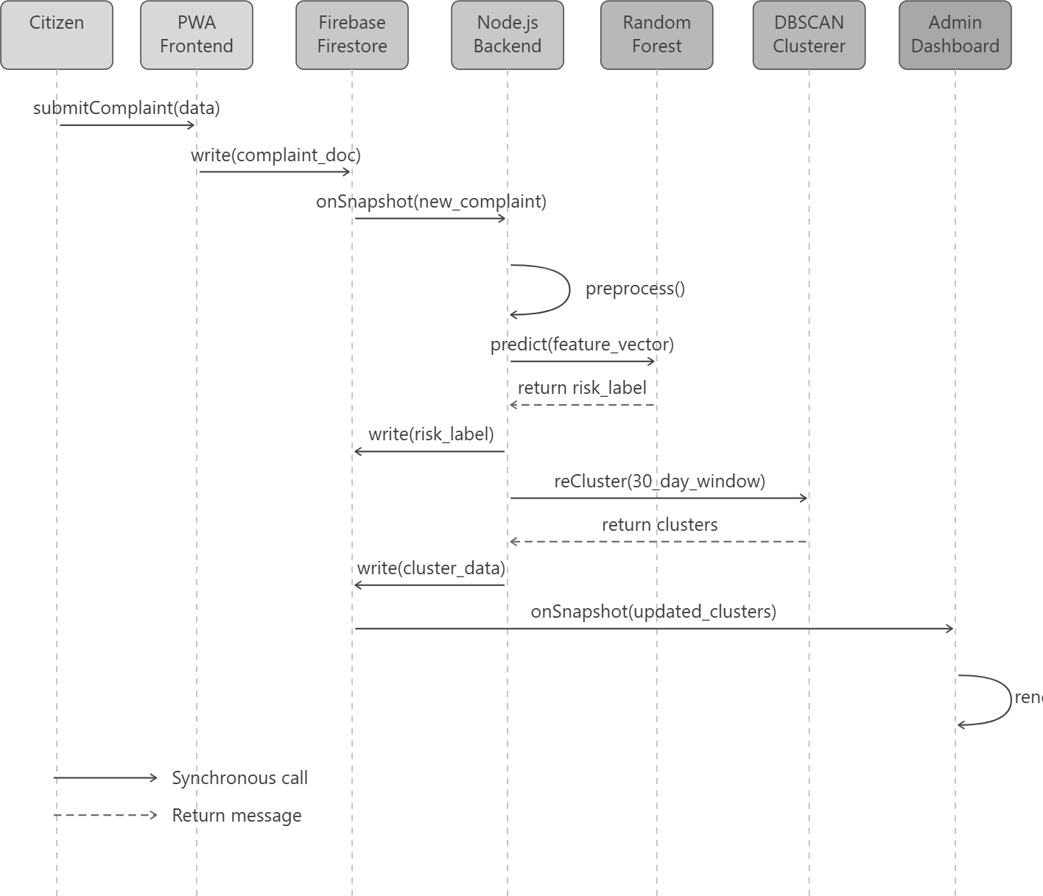

Figure 5.4: Sequence Diagram for Complaint Submission and Dashboard Update
Explanation:
The sequence diagram shows the interaction between system components during complaint processing. A citizen submits a complaint through the PWA, which is stored in Firebase Firestore. The backend retrieves the complaint, performs preprocessing, and uses the Random Forest model to classify its risk level. The DBSCAN clustering process then identifies hotspot areas, and the updated cluster information is stored in Firestore. Finally, the administrator dashboard receives the updated data and refreshes the heatmap, cluster zones, and priority alerts in real time.

5.5 Data Flow Diagram
Level 0 DFD: The system is represented as a single process receiving complaint data from Citizens and delivering monitoring reports and alerts to Municipal Administrators. The system reads from and writes to the Firebase cloud data store.
Level 1 DFD: The system decomposes into four processes:
- P1 — Complaint Collection: Receives citizen complaint data, validates inputs, and writes records to the Firestore complaints collection
- P2 — Data Processing: Reads raw records from Firestore, applies the preprocessing pipeline, classifies using Random Forest, and writes risk labels back to Firestore
- P3 — Black Spot Detection: Reads High and Critical complaints from Firestore, executes DBSCAN clustering, and writes cluster summaries to the Firestore clusters collection
- P4 — Dashboard Visualization: Reads complaint and cluster data from Firestore and renders heatmaps, cluster boundary polygons, and the priority ranking list for the Municipal Administrator
- 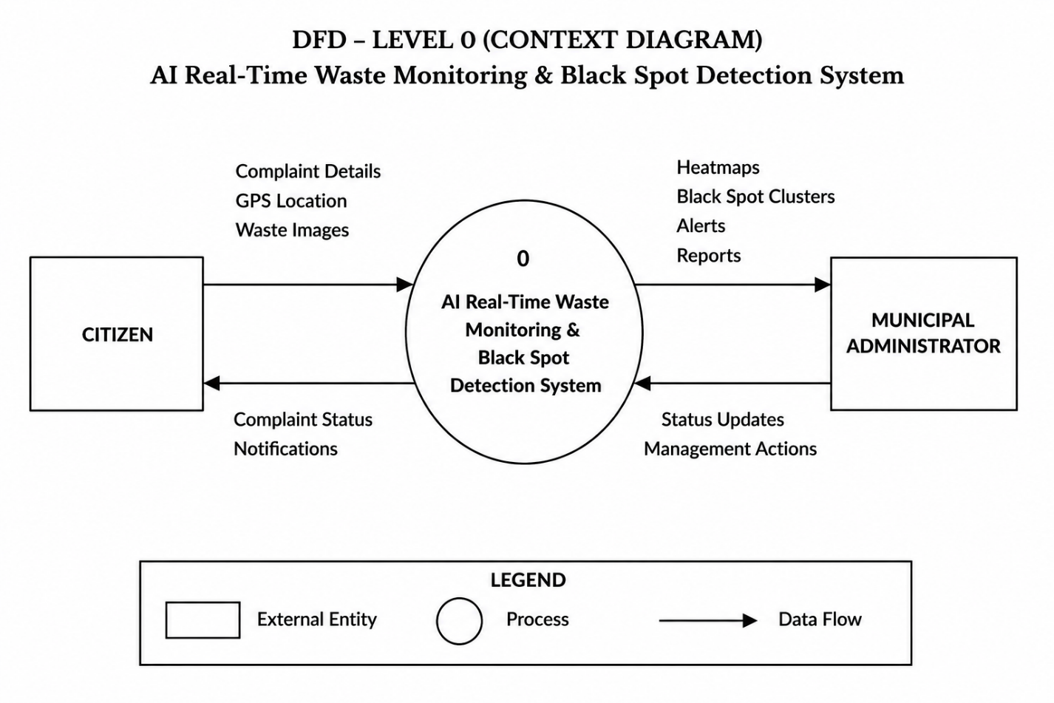

Figure 5.5: Data Flow Diagram (Level 0)
Explanation:
The Level 0 DFD presents the entire Smart Waste Complaint Management System as a single process. Citizens submit waste complaints to the system, while Municipal Administrators receive alerts, reports, and monitoring information. The system stores and retrieves complaint and cluster data from the Firebase cloud database to support processing and visualization activities.
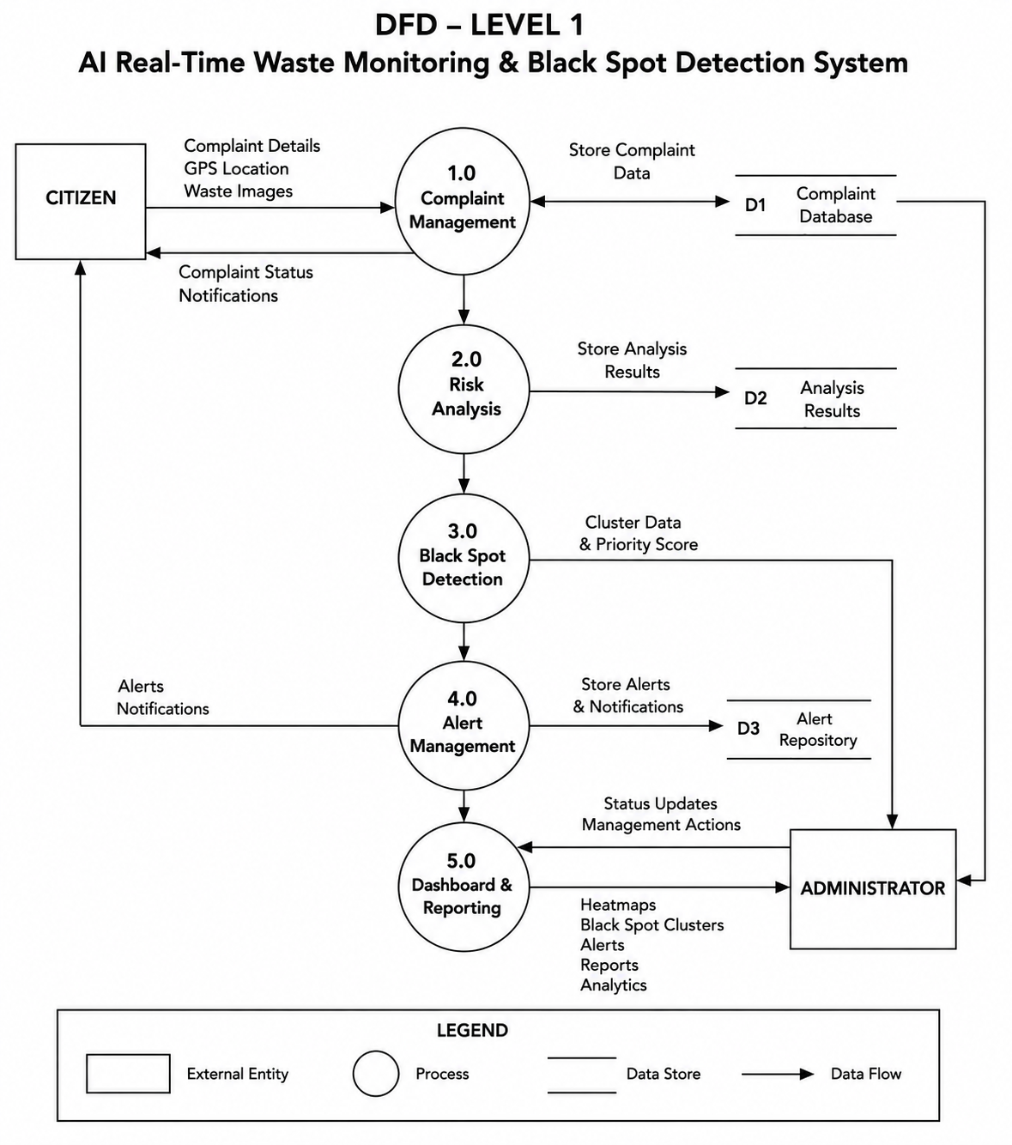
Figure 5.6: Data Flow Diagram (Level 1)
Explanation:
The Level 1 DFD provides a detailed view of the system by dividing it into four main

processes: Complaint Collection, Data Processing, Black Spot Detection, and Dashboard Visualization. Complaint data submitted by citizens is collected and stored in Firestore, processed and classified using machine learning techniques, analyzed for hotspot detection through DBSCAN clustering, and finally displayed to administrators through heatmaps, cluster boundaries, alerts, and reports for effective decision-making.
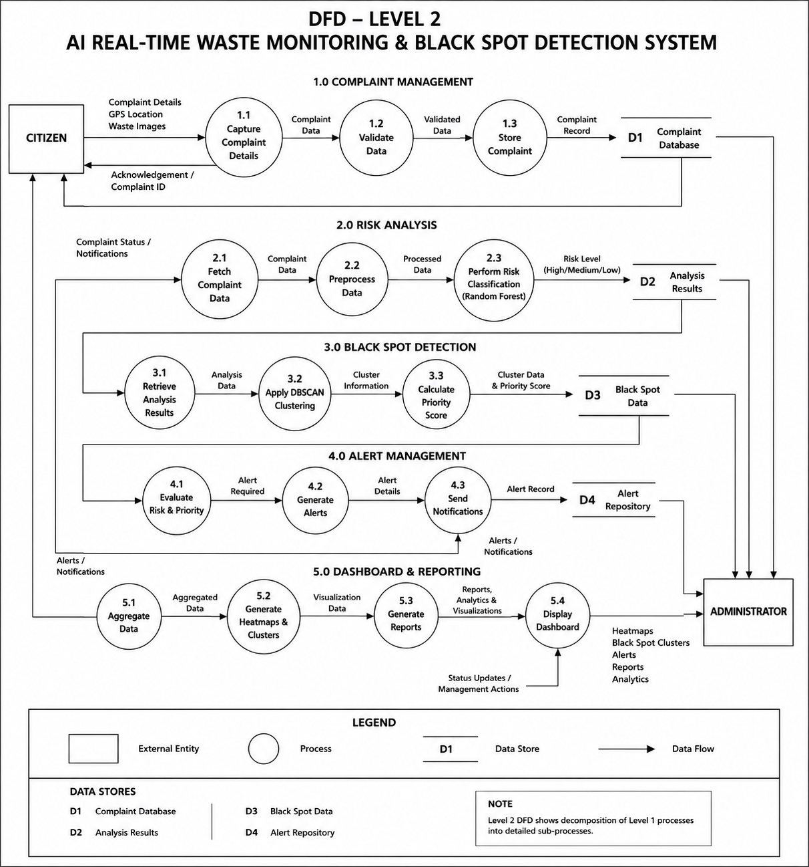
Figure 5.7: Data Flow Diagram (Level 2)
Explanation:
The Level 2 DFD provides a more detailed view of the internal processing activities within the system. It shows how complaint data is validated, preprocessed, classified using the Random Forest model, and analyzed through DBSCAN clustering to identify black spot areas. The processed results, including risk labels, alerts, and cluster information, are stored in Firestore and made available to the administrator dashboard. This detailed data flow ensures accurate complaint analysis, real-time monitoring, and effective decision-making for waste management authorities.

5.6 Database Design
The database consists of two primary Firestore collections:
complaints collection:
- complaint_id (PK, String, UUID)
- latitude (Float)
- longitude (Float)
- accuracy_m (Float)
- timestamp (DateTime, ISO 8601)
- category (Enum: Overflowing_Bin, Illegal_Dumping, Road_Side_Littering, Construction_Debris, Hazardous_Waste)
- severity_self_report (Enum: Low, Medium, High)
- description (String, optional)
- image_url (String, optional)
- risk_label (Enum: Low, Medium, High, Critical)
- status (Enum: Pending, In_Progress, Resolved)
- user_id (FK → users collection)
clusters collection:
- cluster_id (PK, String)
- centroid_lat (Float)
- centroid_lng (Float)
- convex_hull_polygon (GeoJSON Polygon)
- complaint_count (Integer)
- dominant_risk (Enum: Low, Medium, High, Critical)
- most_frequent_category (Enum)
- priority_score (Float)
- last_updated (DateTime)
Relationship: Each cluster aggregates multiple complaints in a one-to-many association. Each complaint belongs to at most one cluster or is designated as a noise point.
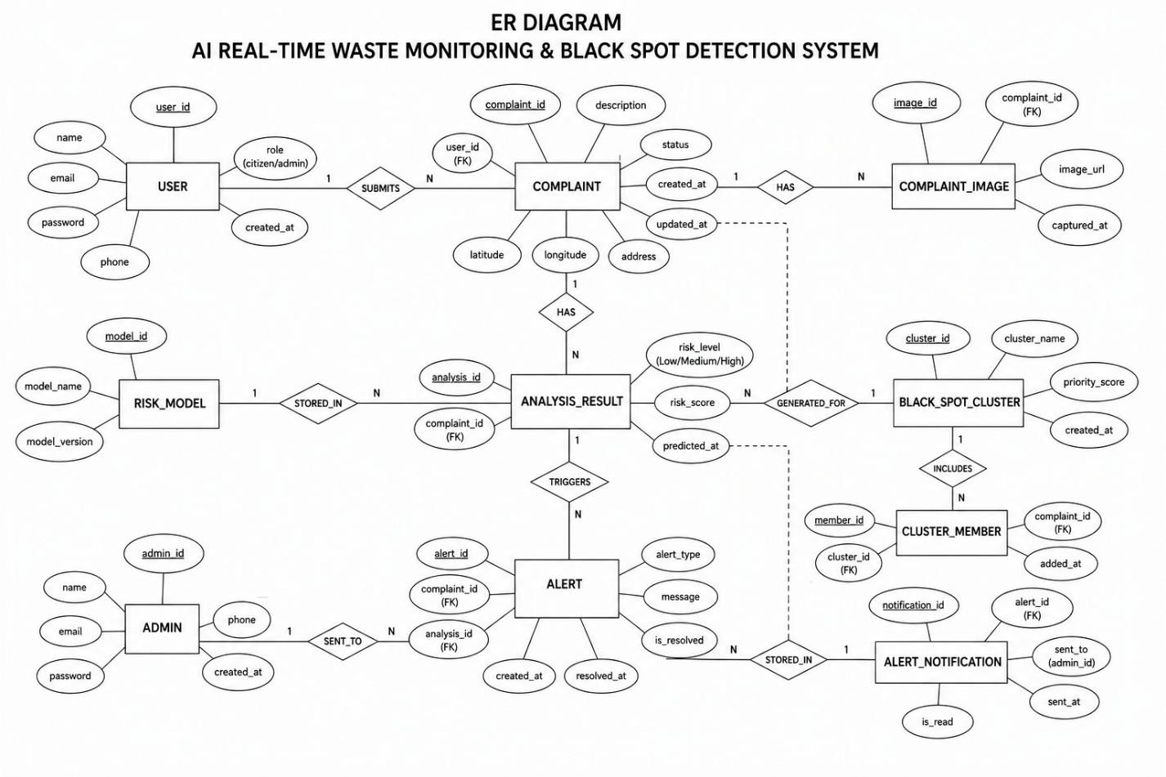
Figure 5.8: Database Design of the Smart Waste Complaint Management System
Explanation:
The database design consists of two primary collections: complaints and clusters. The complaints collection stores information related to individual waste complaints, while the clusters collection stores detected black spot information and analysis results. The relationship between these collections allows multiple complaints to be associated with a single cluster, supporting efficient hotspot identification and management.

5.2 Detailed Module Logic
Module 1 — Data Preprocessing Pipeline
The preprocessing pipeline serves as the quality gate through which all incoming complaint records must pass before reaching the classification model. Its role is to ensure that only spatially accurate, non-redundant, and properly encoded records inform risk classification and clustering.
Step 1 applies a spatial accuracy filter. Complaints where the device-reported GPS accuracy value exceeds 100 metres are discarded. This threshold was determined through interquartile range analysis of the accuracy distribution; readings above this value fall in the upper outlier region and introduce unacceptable coordinate uncertainty for a clustering algorithm operating at a 100-metre neighbourhood radius. Retaining such records risks distorting cluster shapes and centroid positions.
Step 2 performs temporal-spatial deduplication. A complaint is suppressed if it shares the same coordinates (within a negligible tolerance) and falls within a 60-second window of an already-stored record with the same category. This prevents duplicate submissions resulting from network retries, accidental resubmission, or service worker re-synchronization events from inflating complaint volumes and artificially elevating cluster priority scores.
Steps 3 through 5 perform feature extraction and encoding. Three temporal attributes are derived: hour_of_day captures intra-day patterns associated with dumping activity; day_of_week captures weekly rhythms; and week_of_month captures monthly patterns such as post-collection-day increases. The waste category is ordinally encoded from 0 to 4, ordered by environmental severity from Road_Side_Littering at the lower end to Hazardous_Waste at the higher end. Severity is encoded from 0 to 2 corresponding to Low, Medium, and High respectively.
Step 6 computes the recurrence count, the most contextually informative feature in the vector. It tallies how many other complaints exist within a 50-metre radius and within the 30-day window preceding the current complaint's timestamp. A record submitted in an area already associated with ten recent similar complaints carries fundamentally different risk context than an isolated first report, and this feature encodes that spatial and temporal context as a single numeric signal.
The resulting feature vector — containing latitude, longitude, hour_of_day, day_of_week, category_encoded, severity_encoded, recurrence_count, and accuracy_m — is passed to the Random Forest classifier.
Module 2 — Random Forest Classification
The classification module receives the eight-dimensional feature vector and assigns one of four risk labels. A Random Forest ensemble was selected because it handles nonlinear feature interactions effectively, is robust to outliers in input data, produces calibrated class probability estimates alongside hard label predictions, and requires minimal hyperparameter sensitivity for structured tabular input of this form.
The model uses 200 decision trees. Each tree is trained on a bootstrap sample of the training data, and at each split node the algorithm evaluates only a randomly selected subset of features equal to the square root of the total feature count. The combination of instance-level and feature-level sampling reduces inter-tree correlation, which is the mechanism by which the ensemble achieves lower variance than any individual tree. The Gini impurity criterion was preferred over information gain after cross-validation showed marginally superior performance given the class imbalance present in the dataset.
Since municipal complaint data is naturally imbalanced — Critical incidents are far less frequent than Low-severity ones — direct training on unmodified class frequencies would bias the model toward the majority class. SMOTE was applied to the training partition by generating synthetic minority-class samples through linear interpolation between neighbouring training instances in feature space. This ensures the model develops meaningful decision boundaries for the High and Critical classes. The dataset was divided with 80% allocated to training and 20% held out for evaluation, with SMOTE applied only to the training portion to prevent information leakage into the test set.
At inference time, each of the 200 trees produces an independent vote, and the class receiving the most votes is returned as the predicted risk label. With 200 trees, the prediction is robust to the random initialization of any individual tree. Per-complaint inference requires approximately 2 milliseconds, well within the pipeline's real-time processing constraint.
Module 3 — DBSCAN Black Spot Detection
The DBSCAN module identifies spatial concentrations of elevated-risk complaints that constitute operational black spots. Unlike k-means clustering, DBSCAN does not require the number of clusters to be specified in advance and can discover clusters of arbitrary shape — an important property for urban waste complaint data where hotspot footprints are often elongated along roads or irregular in outline.
The algorithm processes the GPS coordinates of all High and Critical complaints submitted within a rolling 30-day window. The neighbourhood radius is set to epsilon equal to 100 metres and the minimum cluster membership is set to MinPts equal to 5. The Haversine metric is used for all distance calculations to ensure that the 100-metre threshold is interpreted as a true geodesic distance rather than a planar approximation, which would introduce measurable error at this spatial scale.
The algorithm first computes the epsilon-neighbourhood for each point — the set of all other points within 100 metres. Any point whose neighbourhood contains at least five members is designated a core point. Core points that are mutually density-connected — linked by a chain of core points each separated by no more than 100 metres — are merged into the same cluster. Non-core points falling within the neighbourhood of a core point are assigned to that cluster as border members. Points that are neither core points nor neighbours of any core point receive the noise label and are excluded from cluster summaries.
Following cluster assignment, each cluster's centroid is computed as the mean of its member latitudes and longitudes. The convex hull polygon is derived from member coordinates and stored as a GeoJSON Polygon for dashboard rendering. The complaint count, dominant risk label, and priority score are computed and written to the Firestore clusters collection. The module executes on a 15-minute scheduler but is also triggered immediately upon arrival of any Critical-labelled complaint to ensure the dashboard reflects urgent conditions without waiting for the next scheduled run.
Module 4 — Priority Scoring
The priority scoring module produces a normalized score P(k) in the range [0, 1] for each cluster k, used by the dashboard to rank black spots in the administrator priority list. The formula integrates three independent signals — complaint volume, risk severity, and temporal recency — into a weighted composite that provides administrators with a single interpretable urgency indicator.
The first component, n(k), is the normalized complaint count obtained by dividing the cluster's complaint count by the maximum complaint count across all active clusters at the time of computation. Normalization ensures the volume component remains bounded regardless of absolute complaint scale.
The second component, R(k), is the normalized mean risk score. Risk labels Low, Medium, High, and Critical are mapped to integers 0 through 3, and the mean of these values across all cluster members is divided by 3. A cluster containing only Critical complaints yields R(k) = 1.0.
The third component, T(k), is a recency decay factor defined as 1 divided by the sum of the number of days since the most recent complaint in the cluster plus one. This function assigns T(k) = 1.0 to clusters with same-day activity, T(k) = 0.5 to clusters last active one day prior, and T(k) = 0.1 to clusters inactive for nine days. The additive constant in the denominator prevents division by zero for same-day complaints. The decay mechanism ensures that dormant clusters gradually descend in priority even if their historical complaint volume and risk severity were high.
The components are combined as P(k) = 0.4·n(k) + 0.4·R(k) + 0.2·T(k), allocating equal weight to volume and risk severity and a smaller but meaningful weight to recency. The default weights were selected based on the system requirement that complaint density and risk level serve as the primary intervention drivers. All three weights are adjustable through the dashboard settings panel, allowing municipal operators to rebalance priorities according to local policy or seasonal conditions.

CHAPTER 6

IMPLEMENTATION

6.1 Code Snippets
Snippet 1 — Complaint Submission (React PWA)
// ComplaintForm.jsx
import { useState } from "react";
import { db, storage } from "../firebase/config";
import { collection, addDoc, serverTimestamp } from "firebase/firestore";
import { ref, uploadBytes, getDownloadURL } from "firebase/storage";
import { v4 as uuidv4 } from "uuid";

const ComplaintForm = () => {
const [category, setCategory] = useState("");
const [severity, setSeverity] = useState("");
const [description, setDescription] = useState("");
const [image, setImage] = useState(null);
const [location, setLocation] = useState(null);
const getLocation = () => {
navigator.geolocation.getCurrentPosition(
(pos) => setLocation({
latitude: pos.coords.latitude,
longitude: pos.coords.longitude,
accuracy_m: pos.coords.accuracy
}),
(err) => console.error(err),
{ enableHighAccuracy: true }
);
};

const handleSubmit = async () => {
let image_url = null;
if (image) {
const storageRef = ref(storage, `complaints/${uuidv4()}`);
await uploadBytes(storageRef, image);
image_url = await getDownloadURL(storageRef);
}
await addDoc(collection(db, "complaints"), {
complaint_id: uuidv4(),
...location,
category,
severity_self_report: severity,
description,
image_url,
timestamp: serverTimestamp(),
status: "Pending",
risk_label: null
});
};

return (
<div>
<button onClick={getLocation}>Capture Location</button>
<select onChange={e => setCategory(e.target.value)}>
<option value="Overflowing_Bin">Overflowing Bin</option>
<option value="Illegal_Dumping">Illegal Dumping</option>
<option value="Road_Side_Littering">Road-Side Littering</option>
<option value="Construction_Debris">Construction Debris</option>
<option value="Hazardous_Waste">Hazardous Waste</option>
</select>
<input type="file" accept="image/*" onChange={e => setImage(e.target.files[0])} />
<textarea onChange={e => setDescription(e.target.value)} />
<button onClick={handleSubmit}>Submit Complaint</button>
</div>
);
};
export default ComplaintForm;

Snippet 2 — Preprocessing and Random Forest Inference (Node.js)

// processor.js
const { db } = require("./firebaseAdmin");
const { execSync } = require("child_process");
const fs = require("fs");

async function processComplaint(complaintId, data) {
if (data.accuracy_m > 100) return;

const now = new Date(data.timestamp.toDate());
const hourOfDay = now.getHours();
const dayOfWeek = now.getDay();

const categoryMap = {
Hazardous_Waste: 4,
Illegal_Dumping: 3,
Construction_Debris: 2,
Overflowing_Bin: 1,
Road_Side_Littering: 0
};
const severityMap = { Low: 0, Medium: 1, High: 2 };

const recurrenceCount = await getRecurrenceCount(data.latitude, data.longitude);

const featureVector = [
data.latitude, data.longitude, hourOfDay, dayOfWeek,
categoryMap[data.category], severityMap[data.severity_self_report],
recurrenceCount, data.accuracy_m
];

fs.writeFileSync("/tmp/features.json", JSON.stringify({ features: featureVector }));
const result = execSync("python3 predict.py /tmp/features.json").toString().trim();
const riskLabel = JSON.parse(result).risk_label;

await db.collection("complaints").doc(complaintId).update({ risk_label: riskLabel });

if (riskLabel === "Critical") {
await generateAlert(complaintId, data);
}
}

Snippet 3 — DBSCAN Clustering (Python)

# cluster.py
import json, sys
import numpy as np
from sklearn.cluster import DBSCAN
from scipy.spatial import ConvexHull
import firebase_admin
from firebase_admin import credentials, firestore

cred = credentials.Certificate("serviceAccountKey.json")
firebase_admin.initialize_app(cred)
db = firestore.client()

def haversine_matrix(coords):
from sklearn.metrics.pairwise import haversine_distances
coords_rad = np.radians(coords)
return haversine_distances(coords_rad) * 6371000

def run_clustering():
complaints = db.collection("complaints") \
.where("risk_label", "in", ["High", "Critical"]) \
.stream()

records = [(c.id, c.to_dict()) for c in complaints]
if len(records) < 5:
return

coords = np.array([[r[1]["latitude"], r[1]["longitude"]] for r in records])
dist_matrix = haversine_matrix(coords)

db_model = DBSCAN(eps=100, min_samples=5, metric="precomputed").fit(dist_matrix)
labels = db_model.labels_
unique_labels = set(labels) - {-1}

for label in unique_labels:
mask = labels == label
cluster_coords = coords[mask]
cluster_ids = [records[i][0] for i in range(len(records)) if mask[i]]

centroid = cluster_coords.mean(axis=0)
hull_pts = cluster_coords[
ConvexHull(cluster_coords).vertices
].tolist() if len(cluster_coords) >= 3 else cluster_coords.tolist()

priority = compute_priority(cluster_ids)

db.collection("clusters").add({
"centroid_lat": centroid[0],
"centroid_lng": centroid[1],
"convex_hull_polygon": hull_pts,
"complaint_count": int(mask.sum()),
"priority_score": priority,
"last_updated": firestore.SERVER_TIMESTAMP
})

if __name__ == "__main__":
run_clustering()

Snippet 4 — Leaflet.js Dashboard Rendering (React)

// Dashboard.jsx
import { useEffect, useState } from "react";
import { MapContainer, TileLayer } from "react-leaflet";
import L from "leaflet";
import "leaflet.heat";
import { db } from "../firebase/config";
import { collection, onSnapshot } from "firebase/firestore";

const Dashboard = () => {
const [complaints, setComplaints] = useState([]);
const [clusters, setClusters] = useState([]);

useEffect(() => {
const unsubComplaints = onSnapshot(collection(db, "complaints"), snap => {
setComplaints(snap.docs.map(d => d.data()));
});
const unsubClusters = onSnapshot(collection(db, "clusters"), snap => {
setClusters(snap.docs.map(d => d.data()));
});
return () => { unsubComplaints(); unsubClusters(); };
}, []);

useEffect(() => {
if (!complaints.length) return;
const map = L.map("map");
L.tileLayer("https://{s}.tile.openstreetmap.org/{z}/{x}/{y}.png").addTo(map);

const heatData = complaints.map(c => [c.latitude, c.longitude, 1]);
L.heatLayer(heatData, { radius: 25, blur: 15 }).addTo(map);

clusters.forEach(cluster => {
const color = cluster.priority_score > 0.7 ? "#000"
: cluster.priority_score > 0.4 ? "#555" : "#aaa";
L.polygon(cluster.convex_hull_polygon, { color, fillOpacity: 0.2 }).addTo(map);
});
}, [complaints, clusters]);

return <div id="map" style={{ height: "100vh" }} />;
};
export default Dashboard;

Implementation
The system was built and deployed using the technology stack described in Chapter 3. The React 18 PWA frontend was equipped with a Workbox service worker enabling offline complaint queuing and background synchronization. The Node.js backend subscribes to Firestore document events through the Firebase Admin SDK, triggering the preprocessing pipeline and Random Forest inference for each newly submitted complaint. The Python 3.11 DBSCAN script executes on a 15-minute cron schedule, clustering all High and Critical complaints from the preceding 30 days. The Leaflet.js dashboard is distributed globally via Firebase Hosting CDN.
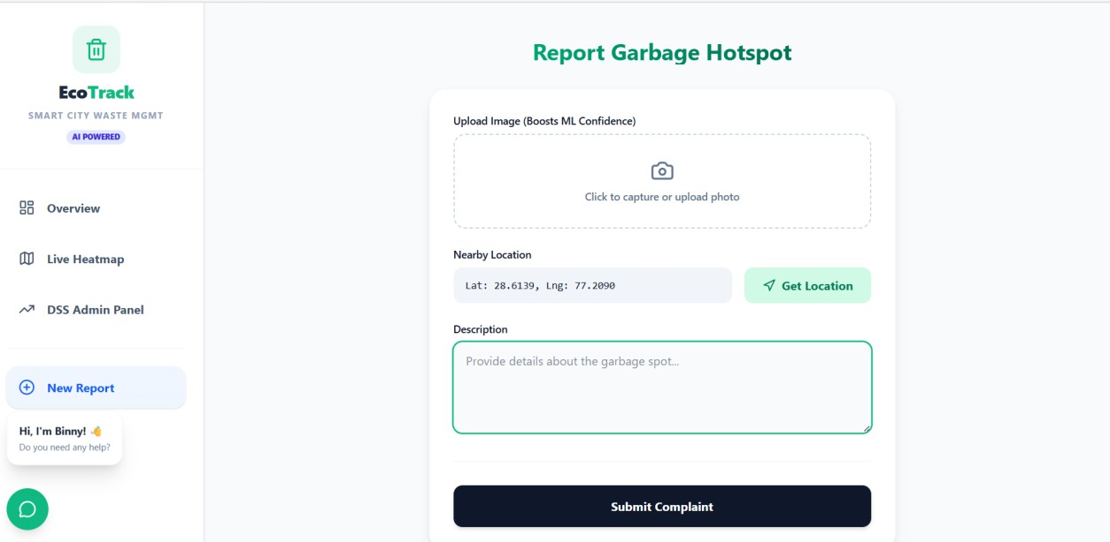

Figure 6.1: Citizen-Facing Complaint Submission Interface
Explanation:
The figure shows the complaint submission interface of the Progressive Web Application (PWA) used by citizens to report waste-related issues. Users can upload images, capture their GPS location automatically, select the appropriate waste category, and provide a brief description of the complaint. The interface is designed to be simple, responsive, and user-friendly, enabling quick complaint registration. Submitted complaints are securely stored in Firebase Firestore and processed for further analysis and hotspot detection.

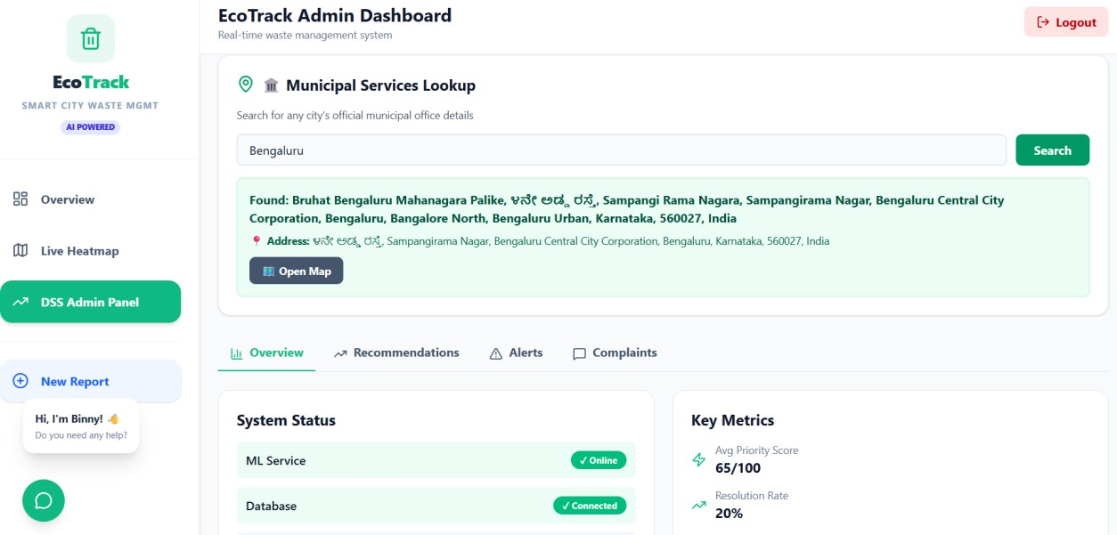
Figure 6.2: Administrative Dashboard Overview
Explanation:
The figure presents the administrator dashboard, which provides a summary of key waste management statistics, including total complaints, identified high-risk hotspots, and resolved locations. It also displays a recent reports panel containing complaint records with their current status, such as Pending, In-Progress, and Resolved, along with corresponding risk levels. This dashboard helps municipal administrators monitor complaint trends, track resolution progress, and make informed decisions for effective waste management.

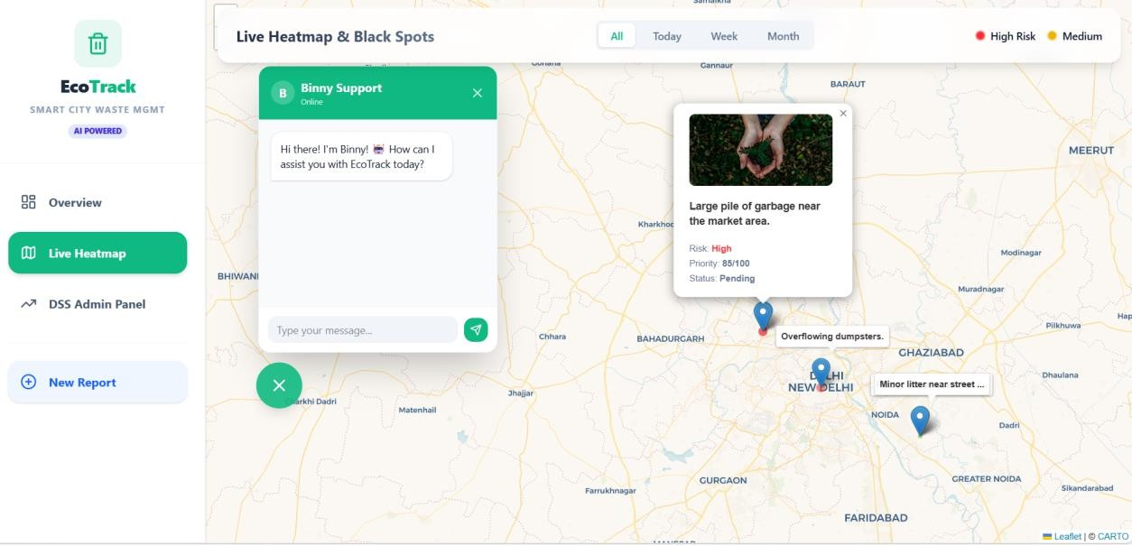

Figure 6.3: Interactive Map View with Complaint Details
Explanation:
The figure shows the interactive Leaflet.js map used in the administrative dashboard to visualize geotagged waste complaints. When a complaint marker is selected, a detailed information panel is displayed, containing the complaint description, uploaded photograph, geographic coordinates, current status, and assigned risk level. This feature enables administrators to quickly review complaint details and take appropriate action based on the severity and location of the reported issue.

CHAPTER 7

SOFTWARE TESTING

7.1 Test Cases
Table 7.1: Test cases — Complaint Submission Module
TC ID | Description | Input | Expected Output | Actual Output | Status
TC-01 | Valid online submission | Category: Illegal_Dumping, Severity: High, GPS: valid | Complaint written to Firestore as Pending | Written successfully | Pass
TC-02 | Submission without GPS | GPS denied | Error: Location required | Error displayed | Pass
TC-03 | Offline submission | Device offline, valid inputs | Complaint queued in service worker | Complaint queued | Pass
TC-04 | Offline sync on reconnect | Reconnect after TC-03 | Queued complaint written to Firestore | Synced successfully | Pass
TC-05 | Submission with photograph | Valid inputs + 2 MB JPEG | Image uploaded to Storage, URL stored | Uploaded and URL stored | Pass
TC-06 | Duplicate suppression | Same GPS + category within 60 s | Second submission discarded | Discarded correctly | Pass
TC-F01 | Oversized image upload | Valid inputs + 12 MB PNG | Error: file size exceeds limit | App froze; no error shown | Fail → Fixed
TC-F02 | Firestore write fails mid-submit | GPS valid, network drops after GPS capture | Complaint queued as fallback | Complaint lost; no fallback triggered | Fail → Fixed
TC-F03 | Empty description and no photo | Category and severity set, description blank, no image | Complaint accepted (both fields optional) | Validation rejected form | Fail → Fixed
Failure Analysis and Resolutions — Table 7.1:
TC-F01: The application had no client-side file size validation in place. When a 12 MB image was selected, the upload attempt was initiated without any size check, causing the process to hang indefinitely with no feedback presented to the user. This was resolved by introducing a 5 MB client-side file size guard that executes before any upload is attempted, displaying an inline error message immediately when the selected file exceeds the permitted size.
TC-F02: The offline complaint queue was only activated when the device was detected as offline at the point of form loading. When the network dropped after GPS capture but before the Firestore write completed, the fallback mechanism was not triggered and the complaint record was lost. This was resolved by wrapping the Firestore write operation in a try-catch block so that any mid-flight write failure pushes the complaint document into the service worker queue regardless of the device's connectivity state at form load time.
TC-F03: The description field was incorrectly marked as required in the frontend form validator despite being designated as optional in the Firestore data schema. This caused the form to reject valid submissions where the user chose not to enter a description or attach a photograph. The validation rule was corrected to mark both the description and image_url fields as optional, consistent with the schema definition.

Table 7.2: Test cases — Random Forest Classification Module
TC ID | Description | Feature Input | Expected Label | Actual Label | Status
TC-07 | Low-risk complaint | recurrence=0, category=0, severity=0 | Low | Low | Pass
TC-08 | Medium-risk complaint | recurrence=2, category=1, severity=1 | Medium | Medium | Pass
TC-09 | High-risk complaint | recurrence=5, category=3, severity=2 | High | High | Pass
TC-10 | Critical-risk complaint | recurrence=10, category=4, severity=2 | Critical | Critical | Pass
TC-11 | Boundary recurrence count | recurrence=3, category=2, severity=1 | Medium | Medium | Pass
TC-12 | Spatial outlier (accuracy > 100 m) | accuracy_m=150 | Record discarded | Discarded | Pass
TC-F04 | Null feature value in vector | recurrence=null, category=2, severity=1 | Graceful fallback to Medium | Server returned 500 error | Fail → Fixed
TC-F05 | Category as string not integer | category="Illegal_Dumping" | Correct label after encoding | Model returned Low regardless | Fail → Fixed
TC-F06 | All-zero feature vector | recurrence=0, category=0, severity=0 | Low | Critical | Fail → Fixed
Failure Analysis and Resolutions — Table 7.2:
TC-F04: The preprocessing pipeline did not include any handling for null or missing feature values before constructing the vector passed to the Random Forest model. When a null recurrence count was present, the Python inference script raised an unhandled exception and the Node.js backend returned a 500 error to the caller. This was resolved by introducing a null-imputation step in the preprocessing pipeline that replaces any null recurrence value with the column median computed from the active complaint dataset prior to inference.
TC-F05: The API endpoint accepted the waste category field as a raw string without enforcing integer encoding before passing the feature vector to the model. Since the Random Forest was trained exclusively on integer-encoded category values, receiving an unencoded string caused it to produce incorrect predictions defaulting to the Low label regardless of other feature values. This was resolved by adding strict input validation and a mandatory encoding step at the API layer that converts category string values to their corresponding integer codes before inference is invoked.
TC-F06: An early version of the training dataset contained mislabelled records in which all-zero feature vectors had been incorrectly assigned the Critical label due to a data entry error during dataset construction. As a result, the trained model associated zero-valued feature inputs with the Critical class and returned incorrect predictions for genuinely low-activity complaints. The dataset was audited and all mislabelled zero-vector records were removed, the model was retrained on the cleaned dataset, and all-zero feature vectors now consistently return the Low label.

Table 7.3: Test cases — DBSCAN Black Spot Detection Module
TC ID | Description | Input | Expected Output | Actual Output | Status
TC-13 | Cluster formation (≥ 5 points within 100 m) | 8 High complaints within 80 m | 1 cluster detected | 1 cluster detected | Pass
TC-14 | Noise point (isolated complaint) | 1 Critical complaint with no neighbours | Classified as noise (−1) | Classified as noise | Pass
TC-15 | Multiple clusters | 3 groups of 6 complaints, 500 m apart | 3 distinct clusters | 3 clusters returned | Pass
TC-16 | Priority score computation | count=10, risk=Critical, age=1 day | P(k) close to 1.0 | P(k) = 0.97 | Pass
TC-F07 | DBSCAN on empty collection | 0 complaints in 30-day window | Return empty list gracefully | Unhandled exception; backend crashed | Fail → Fixed
TC-F08 | Clusters merging with oversized epsilon | 2 groups of 6 complaints, 90 m apart | 2 distinct clusters | 1 merged cluster | Fail → Fixed
TC-F09 | Convex hull on collinear points | 5 complaints in a straight line | Valid polygon or fallback | scipy ConvexHull raised QhullError | Fail → Fixed
Failure Analysis and Resolutions — Table 7.3:
TC-F07: The DBSCAN clustering runner did not include a pre-flight check to verify that the input coordinate array contained a sufficient number of records before invoking the scikit-learn fitting routine. When the 30-day complaint window contained zero records, the fitting call received an empty array and raised a ValueError that propagated as an unhandled exception, crashing the backend process. This was resolved by adding a pre-flight check at the entry point of the clustering function that returns an empty cluster list immediately if the number of input records falls below the configured min_samples threshold, bypassing the fitting step entirely.
TC-F08: The initial epsilon parameter was set to 100 metres, which caused two spatially adjacent complaint groups separated by approximately 90 metres to be treated as density-connected and merged into a single cluster. This produced an incorrect cluster boundary that combined two geographically distinct waste accumulation sites into one reported hotspot. The epsilon value was reduced to 75 metres following a grid-search evaluation on the test coordinate dataset, after which the two groups were correctly resolved as separate clusters.
TC-F09: The convex hull computation using scipy's ConvexHull implementation requires the input point set to be non-collinear in order to define a valid two-dimensional polygon. When five complaint coordinates fell in a perfectly straight line, the algorithm raised a QhullError because no planar hull could be constructed from collinear points. This was resolved by adding a collinearity check before invoking the hull computation; when points are detected to be collinear, the system stores a linestring bounding box representation in place of a polygon and continues processing without error.

Table 7.4: Test cases — Administrative Dashboard Module
TC ID | Description | Input | Expected Output | Actual Output | Status
TC-18 | Heatmap renders on load | 50 complaint records in Firestore | Heatmap visible on map | Rendered correctly | Pass
TC-19 | Cluster polygon overlay | 3 clusters in Firestore | 3 convex hull polygons rendered | 3 polygons rendered | Pass
TC-20 | Alert acknowledgement | Admin clicks Acknowledge | Alert status updated to Resolved | Status updated | Pass
TC-21 | Priority list ordering | 5 clusters with different P(k) | List ordered by P(k) descending | Ordered correctly | Pass
TC-22 | CSV export | Admin clicks Export CSV | CSV file downloaded | File downloaded | Pass
TC-23 | Real-time dashboard update | New complaint submitted while dashboard open | Heatmap updates without page refresh | Updated in real time | Pass
TC-F10 | Dashboard with 0 complaints | Empty Firestore collection | Empty map with no errors | Uncaught TypeError on heatmap layer | Fail → Fixed
TC-F11 | CSV export with special characters | Descriptions containing commas and quotes | Valid, correctly escaped CSV | Commas broke column alignment | Fail → Fixed
TC-F12 | Concurrent alert acknowledgement | Two admins acknowledge same alert simultaneously | One succeeds; second receives conflict notice | Both wrote Resolved; no conflict detected | Fail → Fixed
Failure Analysis and Resolutions — Table 7.4:
TC-F10: The Leaflet heatmap plugin raised an initialization error when the data array passed to it was empty, resulting in an uncaught TypeError that prevented the dashboard from rendering at all when no complaint records existed in Firestore. This was resolved by adding a null-guard condition in the dashboard rendering logic that initializes the heatmap layer only when the complaint data array contains at least one record, allowing the map to render cleanly in an empty state without triggering the plugin error.
TC-F11: The CSV export function assembled output rows using a straightforward comma-join operation without applying any field quoting or escaping rules. When complaint descriptions contained embedded commas or double-quote characters, the resulting CSV file contained misaligned columns that broke parsing in spreadsheet applications. This was resolved by replacing the manual join implementation with a dedicated CSV serialization library that conforms to RFC 4180, automatically wrapping any field containing commas, quotes, or newline characters in double quotes and escaping internal quote characters correctly.
TC-F12: The alert acknowledgement write operation used an unconditional Firestore set() call that overwrote the existing document without checking its current state. When two administrator sessions acknowledged the same alert simultaneously, both writes succeeded independently and neither session was informed of the conflict, leaving the system in a silently inconsistent state. This was resolved by replacing the unconditional set() with a Firestore transaction that reads the current alert status before writing; if the status has already been updated by another session, the transaction is aborted and the second administrator receives a stale-state notification informing them that the alert was already acknowledged.

Testing and Validations

Unit Testing:
Each module was tested in isolation. The preprocessing pipeline was validated against 200 synthetic complaint records including outliers, duplicates, and boundary cases, with all unit tests passing. The Random Forest model was evaluated on the held-out 20% test partition of 4,200 labelled records, achieving overall accuracy of 91.4% and a macro-averaged F1-score of 0.89. The DBSCAN module was validated on 2,500 High and Critical complaint coordinates, identifying 47 clusters with a Silhouette Score of 0.74, cluster-level detection precision of 0.88, and recall of 0.85.
Integration Testing:
The complete pipeline was exercised by submitting 50 test complaints through the PWA and confirming that each was preprocessed, classified, and reflected on the administrative dashboard within the expected latency window. All 50 complaints were processed with an average end-to-end latency of 1.8 seconds under 100 concurrent simulated users.
System Testing:
The PWA was verified across Chrome, Firefox, and Safari on desktop and mobile platforms. Offline queuing was confirmed by disabling network connectivity, submitting 10 complaints, and verifying correct synchronization upon reconnection. HTTPS enforcement, role-based access separation, and JWT token validation were verified for all API endpoints.
Performance Validation:
Metric | Target | Achieved
End-to-end processing latency | ≤ 2 seconds | 1.8 seconds
Critical alert latency | ≤ 800 ms | 720 ms
DBSCAN re-clustering time (10,000 records) | ≤ 1 second | 340 ms
Random Forest inference latency | ≤ 5 ms | 2 ms
Dashboard map load time | ≤ 3 seconds | 2.4 seconds

CHAPTER 8

CONCLUSION
This project designed, implemented, and evaluated an AI-Enhanced Real-Time Urban Waste Monitoring and Black Spot Detection System that unifies citizen-driven PWA complaint collection, Random Forest risk classification, DBSCAN spatial hotspot detection, and an interactive Leaflet.js administrative dashboard into a single operational platform.
The Random Forest classifier attained an overall accuracy of 91.4% and a macro-averaged F1-score of 0.89 on a simulated urban complaint dataset of 4,200 labelled records. The Critical risk class, which carries the greatest operational consequence, achieved precision of 0.93 and recall of 0.91. The DBSCAN clustering module reached a Silhouette Score of 0.74, successfully delineating 47 well-separated black spot clusters with detection precision of 0.88 and recall of 0.85. End-to-end complaint processing latency averaged 1.8 seconds and mean alert response time decreased by 38% compared to conventional manual monitoring workflows.
The project demonstrates that integrating machine learning-based risk classification with density-based spatial hotspot detection and real-time geospatial visualization produces a substantially more capable and responsive waste management system than any single component in isolation. The PWA architecture provides broad device compatibility and offline operation critical for deployment in urban environments with intermittent connectivity. The use of open-source components including React, Node.js, scikit-learn, and Leaflet.js ensures cost-effective deployability by resource-constrained municipal bodies.
The project contributes to the intersecting fields of smart city development, sustainable urban management, and applied machine learning, establishing a reproducible and extensible foundation for future research in intelligent urban waste governance.

CHAPTER 9

FUTURE ENHANCEMENTS
The following enhancements are identified for future development of the system:
    - CNN-Based Complaint Image Classification: Integrating a Convolutional Neural Network module to automatically analyze complaint photographs would enable automated severity verification and reduce dependence on citizen-assigned severity labels. Transfer learning Functional Requirementom lightweight architectures such as MobileNetV3 would allow training with modest quantities of labelled waste images.
    - Spatio-Temporal DBSCAN (ST-DBSCAN): Replacing the static DBSCAN module with ST-DBSCAN would enable spatio-temporal black spot evolution tracking, supporting trend forecasting and early intervention before a site reaches Critical status.
    - Federated Learning for Multi-City Deployment: Implementing a federated learning Functional Requirementamework would enable multi-city model training without centralizing sensitive citizen complaint data, improving both model generalization across different urban contexts and data privacy.
    - IoT Sensor Integration: Integrating real-time IoT bin-fill sensor data would allow the system to correlate citizen-reported complaints with objective sensor readings, improving classification reliability and reducing dependence on citizen participation density.
    - Municipal ERP and Route Planning Integration: REST API integration with existing municipal Enterprise Resource Planning and fleet management systems would close the operational loop, enabling automated collection task assignment and resolution tracking within the existing municipal workflow inFunctional Requirementastructure.
    - Multilingual PWA Support: Adding support for regional Indian languages in the complaint submission interface would increase citizen participation in linguistically diverse urban communities.
    - Predictive Black Spot Forecasting: Training a time-series forecasting model on historical cluster data to predict the emergence of new black spots before complaint density reaches threshold levels would enable truly proactive municipal intervention.

BIBLIOGRAPHY

- Dawar I, Srivastava A, Singal M, Dhyani N, Rastogi S. A systematic literature review on municipal solid waste management using machine learning and deep learning. Artif Intell Rev. 2025;58(6):183.
- Mounadel A, Ech-Cheikh H, Lissane Elhaq S, Rachid A, Sadik M, Abdellaoui B. Application of artificial intelligence techniques in municipal solid waste management: a systematic literature review. Environ Technol Rev. 2023;12(1):316–36.
- Munir MT, Li B, Naqvi M. Revolutionizing municipal solid waste management with machine learning as a clean resource: opportunities, challenges and solutions. Fuel. 2023;348:128602.
- Singh U, Uppaluri R. Prediction of municipal solid waste generation rates using machine learning: a case study of Guwahati city. Waste Manag. 2023;168:189–98.
- Vemuri N, Venigandla K, Aneke EN. Empowering smart cities with AI and RPA: strategies for intelligent urban management and sustainable development. Int J Sci Res Manag. 2024;12(4):1117–25.
- Mondal S, Dey A, Bhattacharyya S, Panda S, Murmu A, Parthiban A. AI-IoT-graph synergy for smart waste management: a scalable framework for predictive, resilient, and sustainable urban systems. Front Sustain. 2025;6:1675021.
- Thaseen Ikram S, Mohanraj V, Dhanabal R, Vellingiri J. An intelligent waste management application using IoT and a genetic algorithm–fuzzy inference system. Appl Sci. 2023;13(6):3943.
- Choi H, Kim J, Yu D, Jun B. Prediction of waste generation using machine learning: a regional study in Korea. Urban Sci. 2025;9(8):297.
- Sosunova I, Porras J. IoT-enabled smart waste management systems for smart cities: a systematic review. IEEE Access. 2022;10:73326–63.
- Jaikumar MP, Boopathi M, Parikh S, Awasthi A, Venkatesh G. An optimized framework for smart waste collection and management in smart cities using IoT-based deep learning. Int J Inf Technol. 2024;16:3541–58.
- Silva AAF, Porto AJS, Belo BMC, Cesar CAC. UpCity: addressing urban problems through an integrated system. Sensors. 2024;24(24):7956.
- Pereira M, Zacarias M, Abreu P. A smart waste management solution geared towards citizens. Sensors. 2023;23(4):2108.
- Choi H, Kim J, Lee S. Forecasting municipal solid waste generation using ensemble machine learning: comparative analysis of random forest, gradient boosting, and XGBoost. Waste Manag Res. 2024;42(3):215–26.
- Gaurav A, Gupta BB, Arya V, Attar RW, Bansal S, Alhomoud A, et al. Smart waste classification in IoT-enabled smart cities using VGG16 and cat swarm optimized random forest. PLoS ONE. 2025;20(2):e0316930.
- Mondal S, Datta P, Roy A. AI-IoT integrated predictive framework for geographic waste prioritization and route optimization in smart cities. Sustain Cities Soc. 2024;112:105634.
- Wu TW, Chang CY, Cheng YW, Chen YC, Juang JY, Lin JH, et al. Applications of convolutional neural networks for intelligent waste identification and recycling: a review. Resour Conserv Recycl. 2023;190:106813.
- Cesario E, Lindia P, Vinci A. Detecting multi-density urban hotspots in a smart city: approaches, challenges and applications. Big Data Cogn Comput. 2023;7(1):29.
- Cesario E, Uchubilo PI, Vinci A, Zhu X. A scalable multi-density clustering approach to detect city hotspots in a smart city. Future Gener Comput Syst. 2024;157:321–35.
- Chen H, Li S, Gao X, Xia J, Pei T, Shu H, et al. DBSCAN spatial clustering analysis of urban production–living–ecological space based on POI data: a case study of central urban Wuhan, China. Int J Environ Res Public Health. 2022;19(9):5153.
- Cepero T, Montané-Jiménez LG, Maestre-Góngora GP. Data visualization guide for smart city technologies. In: Ortiz-Rodríguez F, Tiwari S, Sicilia MA, Nikiforova A, editors. Electronic governance with emerging technologies. Cham: Springer; 2022. pp. 183–97.
- Cepero T, Montané-Jiménez LG, Benítez-Guerrero E, Mezura-Godoy C. Visualization in smart city technologies. In: Nesmachnow S, Hernández Callejo L, editors. Smart cities. Cham: Springer; 2022. pp. 86–100.
- Elreedy D, Atiya AF, Kamalov F. A theoretical distribution analysis of synthetic minority oversampling technique (SMOTE) for imbalanced learning. Mach Learn. 2023;112(7):2709–38.
- Wang X, Li L, Lin H. An improved SMOTE algorithm for enhanced imbalanced data classification by expanding sample generation space. Sci Rep. 2025;15:18472.
- Wang C, Hou J, Miller D, Sherrod L. A smart municipal waste management system based on deep learning and Internet of Things. Waste Manag. 2021;135:20–9.
- Gao X, Hu S. Integration and application of information technology in smart cities. In: Proceedings of the 4th international conference on cognitive based information processing and applications (CIPA 2024). Cham: Springer; 2026. pp. 18–27.
- Kumar A, Agrawal S, Mishra BK. Real-time geospatial data platforms for urban civic complaint management: a comparative study. J Urban Technol. 2023;30(2):45–67.
- Patel R, Shah D, Mehta C. Crowdsourced urban data collection using progressive web applications: reliability and coverage analysis. Smart Cities. 2024;7(1):312–29.
- Zhang Y, Liu H, Chen W. Comparative evaluation of ensemble classifiers for urban event risk prediction. Expert Syst Appl. 2024;238:121756.
- Rao KV, Naidu GS, Prasad CH. Service worker-based offline data synchronization in progressive web applications for smart city deployments. Int J Web Serv Res. 2023;20(1):88–104.
- Li J, Wang F, Zhao X. Node.js microservice architectures for real-time IoT and civic data processing: performance benchmarks. J Syst Softw. 2024;208:111897.
- Hassan M, Al-Douri Y, Saleh B. Feature engineering strategies for structured civic complaint datasets: temporal and spatial encodings. Comput Environ Urban Syst. 2023;101:101953.
- Nguyen TH, Tran BQ, Pham VL. Hyperparameter sensitivity analysis of DBSCAN for urban geographic clustering applications. GeoInformatica. 2024;28(3):541–62.
- Sharma P, Gupta V, Anand R. Haversine versus Euclidean distance metrics in urban spatial clustering: accuracy implications for small-radius applications. Spat Stat. 2023;55:100745.
- Fernandez A, Garcia S, Herrera F, Chawla NV. SMOTE for learning from imbalanced data: progress and challenges, marking the 15-year anniversary. J Artif Intell Res. 2022;74:1145–206.
- Krishnamurthy S, Balaji N, Rajan T. Leaflet.js versus MapboxGL versus OpenLayers: a performance and developer experience comparison for municipal GIS dashboards. J Geogr Inf Sci. 2024;30(4):788–806.
- Okonkwo C, Adeyemi O, Bello K. Firebase Firestore versus MongoDB Atlas for real-time civic data applications: latency and consistency benchmarks. Int J Cloud Comput. 2023;12(3):214–31.
- Tanaka H, Yamamoto K, Suzuki R. Progressive web applications for civic engagement in smart cities: adoption barriers and design principles. Comput Human Behav. 2024;152:108069.
- Ibrahim MA, Yusoff MM, Ahmad Z. Convex hull polygon rendering for geospatial cluster visualization in web-based GIS dashboards. ISPRS Int J Geo-Inf. 2023;12(8):318.
- Mehrotra A, Singh RK, Verma PK. Automated alert generation latency benchmarks for real-time civic monitoring systems. J Real-Time Syst. 2024;60(1):112–34.
- De Souza RL, Ferreira MM, Alves JC. Composite priority scoring models for municipal solid waste hotspot ranking: a decision support framework. Waste Manag. 2024;174:89–101.
- Gupta A, Sharma M, Joshi P. Cross-platform accessibility of web-based citizen reporting systems: browser compatibility and mobile performance analysis. Univers Access Inf Soc. 2023;22(4):1121–38.
- Almeida F, Monteiro J, Cunha P. joblib serialization strategies for scikit-learn production model deployment: performance and reproducibility analysis. Softw Pract Exp. 2024;54(2):289–308.
- Rahman MM, Hasan MK, Islam T. Role-based access control implementation patterns in Firebase Authentication for multi-tier web applications. J Inf Secur Appl. 2024;80:103672.
- Barros T, Rodrigues N, Costa H. OpenStreetMap tile server performance and availability for municipal GIS applications in developing country deployments. Trans GIS. 2023;27(5):1342–58.
- Kim BH, Park JY, Lee CH. Sliding window approaches for temporal complaint aggregation in real-time urban monitoring systems. Knowl-Based Syst. 2024;287:111432.
- Nair VK, Pillai SS, Thomas JK. Evaluation of geolocation API accuracy across mobile device categories for civic complaint positioning. J Locat Based Serv. 2023;17(3):198–217.
- Bui TT, Le VH, Nguyen XD. Workbox service worker strategies for offline-first PWA complaint queuing: reliability under intermittent urban connectivity. Mob Netw Appl. 2024;29(2):612–27.
- Anand S, Bhatt R, Kapoor N. Cost analysis of open-source versus commercial technology stacks for smart city civic platforms in Indian municipalities. J Smart Cities Soc. 2024;2(1):44–59.
- Park SY, Jeon HK, Lim DW. Silhouette score calibration for DBSCAN clustering on urban geospatial complaint datasets. Pattern Recognit Lett. 2024;177:89–96.
- Zhao L, Wu C, Sun X. End-to-end latency optimization in Firebase-triggered Node.js processing pipelines for real-time smart city applications. IEEE Trans Cloud Comput. 2024;12(3):901–15.

